Exercise: Image Verification 1
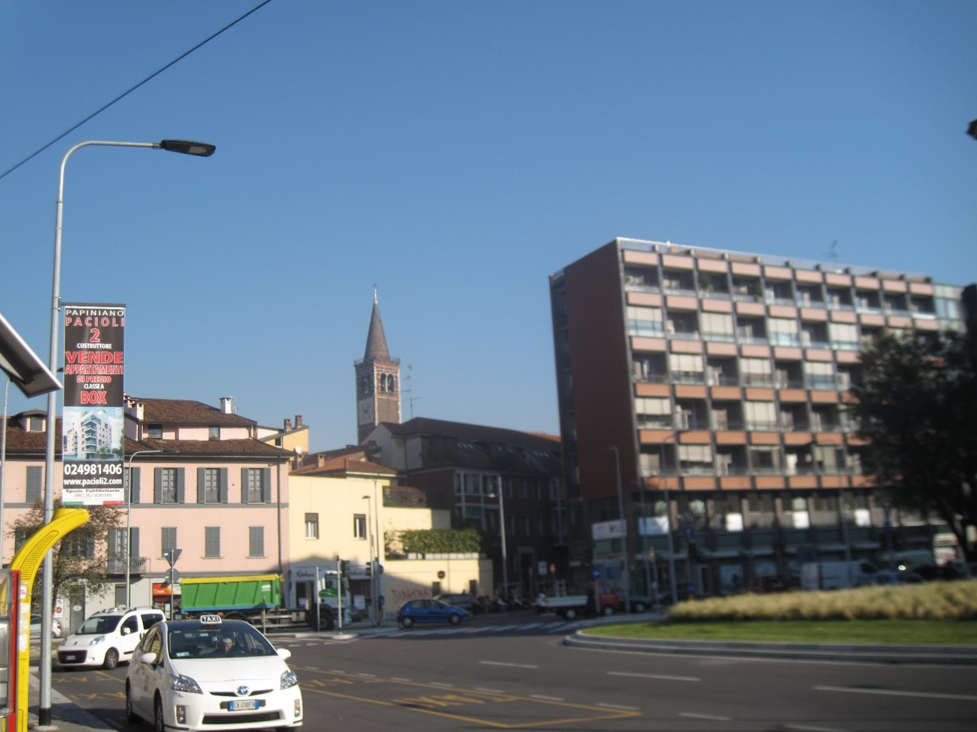
In which country and city this photo was taken? Describe in detail the method you followed.

Exercise: Image Verification 2
In which country and city, address, and date the photo was taken. Describe in detail the method you followed. Access the image file.
