Media discourses about climate change
This module is composed of 5 lessons of 45 minutes each. The file presenting the module contains a list of self-study materials
Lesson 1
Read the article below and summarize its main points for the first lesson.
You can also access the piece via the following link:
https://yaleclimateconnections.org/2021/07/death-valley-california-breaks-the-all-time-world-heat-record-for-the-second-year-in-a-row/
Death Valley, California, breaks the all-time world heat record for the second year in a row
If verified, the 130 degrees Fahrenheit (54.4°C) reading at the Furnace Creek Visitor's Center on Friday, July 9, 2021, would be Earth's highest reliably measured temperature.
by JEFF MASTERSJULY 12, 2021
For the second consecutive year, Death Valley, California, has set a world record for the hottest reliably measured temperature in Earth’s history.
Death Valley National Park’s Furnace Creek Visitor Center hit an astonishing 130.0 degrees Fahrenheit (54.4°C) on Friday afternoon, July 9, 2021, beating the previous world record of 129.9 degrees Fahrenheit (54.4°C), set there on August 16, 2020. For perspective, according to What’s Cooking America, a medium-rare steak is cooked to an internal temperature of 130-135°F.
According to weather records expert Christopher Burt, who wrote the comprehensive weather records book Extreme Weather, and extreme weather expert Maximiliano Herrera, who tweets under the Twitter handle Extreme Temperatures Around the World, the observation, if confirmed, would be the hottest reliably recorded temperature in world history.
Cautions about the record
Friday’s measurement will have to undergo review by the World Meteorological Organization (WMO) before being declared officially valid. Two possible areas of concern are that the temperatures at Furnace Creek showed a steep jump during the afternoon, and the nearby Stovepipe Wells station was considerably cooler, topping out at 122.6 degrees Fahrenheit (50.3°C). (See the raw high-resolution Furnace Creek data here by choosing a time up to six days in the past from the drop-down menu, then choosing “Decoded Data”.) WMO has not yet certified last year’s 129.9 degrees Fahrenheit (54.4°C) reading on August 16, 2020 at Furnace Creek as valid, so there may be a long wait. Fortunately, we’ll have excellent independent verification of this year’s measurement thanks to a temporary thermometer set up at the site in May by Campbell Scientific.
Climatologist William Reid, an expert on Death Valley meteorology who has written extensively about the site, cautioned that an increase in vegetation and structures built in the vicinity of the Furnace Creek site in recent decades has allowed the station to record hotter temperatures.
“An increase in vegetation and some man-made structures not too far south of the station have resulted in poorer ventilation through the station area. Since the station is above a bare and sandy surface, hot air along the ground during afternoon sunshine is less effectively mixed away from the instrumentation. The result is higher temperature readings during the afternoon comparably,” Reid wrote. “I figure that most summer maximums at Death Valley today are a couple of degrees higher because of the poorer station exposure. A day that hits 125 degrees today probably would have only been as high as 122-123 degrees before 1980.”
Figure 1. Hourly maximum temperature at Death Valley National Park’s Furnace Creek Visitor Center July 6-12, 2021. (Image credit: NOAA)
Official world record remains 134°F at Furnace Creek in 1913
“If Friday’s observation passes an investigation (instrument calibration, etc.) then, yes, this is a new reliably measured global extreme heat record,” Burt wrote by email.
But the observation will not count as an official world record. In 2013, WMO officially decertified the official all-time hottest temperature in world history, a 136.4 degrees Fahrenheit (58.0°C) reading from Al Azizia, Libya, in 1923. (Burt was a member of the WMO team that made the determination.) With the Libya record abandoned, the official world record was given to a 134 degrees Fahrenheit (56.7°C) measurement taken at Death Valley on July 10, 1913.
However, this record has been strongly disputed by Burt, Herrera, and Reid.
“The old Death Valley record from July 1913 is 100% bogus (not just 99.9% such), as are all other temperature readings of 130 degrees Fahrenheit or higher from Africa in the past,” Burt said.
Burt wrote a detailed 2016 blog post at Weather Underground challenging the 1913 record at Death Valley, explaining that official readings of 134, 130, and 131 degrees Fahrenheit taken on July 10, 12, and 13, 1913 were likely the result of an inexperienced observer. Climatologist William Reid has also extensively researched what he calls an “improbable record” in 1913. In order for the 1913 Death Valley record to be decertified, though, an official WMO investigation committee would have to be assembled to look into the matter, a years-long process for which there is currently no motivation.
The only other temperature of at least 130 degrees Fahrenheit officially recognized by WMO is a 131-degree reading at Kebili, Tunisia, set July 7, 1931, which is considered to be Africa’s hottest temperature.
Burt disputed this record: “I mentioned to the WMO about the Kebili temperature of 131 degrees Fahrenheit back in 2012, when asked what I thought the next hottest temperature in Africa (after Al Azzia) might be, since that was the only temperature over 130 degrees Fahrenheit that had an actual date attached to it. However, the Kebili ‘record’ is even more bogus than even the Al Azzia record, and I said so. Kebili is a relatively cool spot in Tunisia (an oasis) and never since the 1930s ever again recorded a maximum temperature above 118 degrees Fahrenheit. Nowhere in Africa has any reliably observed temperature been measured above 126 degrees Fahrenheit.”

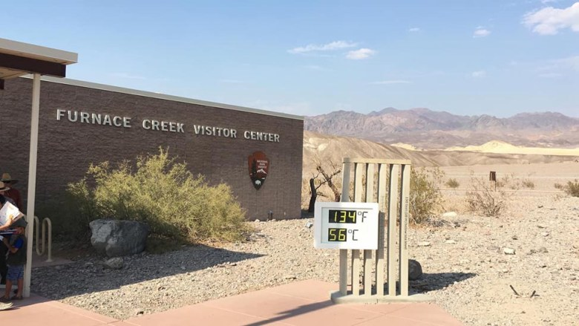Figure 2. The unofficial thermometer at Death Valley National Park’s Furnace Creek Visitor Center (which reads about 5°F too high, compared to the official instrument), as seen on Saturday afternoon, July 10, 2021. Earth’s third-hottest reliably measured temperature in history, 54.1° C (129.4°F), was recorded that day at the site. (Image credit: William Reid)
Top-10 list of hottest world temperatures: Furnace Creek dominates
Furnace Creek made a run at beating its Friday world record on Saturday, but according to an email from climatologist William Reid, who visited Death Valley that day, high clouds moved over the station in the afternoon, allowing the temperature to reach “only” 129.4 degrees Fahrenheit (54.1°C). Even so, the highs Friday and Saturday mean that the planet’s top three hottest reliably measured temperatures on record have all occurred at Furnace Creek in the past year. Here’s is Earth’s top-ten list of hottest reliably measured temperatures:
1) 54.4° C (130.0°F), 7/09/2021, Furnace Creek (California, U.S.);
2) 54.4° C (129.9°F), 8/16/2020, Furnace Creek (California, U.S.);
3) 54.1° C (129.4°F), 7/10/2021, Furnace Creek (California, U.S.);
4) 54.0° C (129.2°F), 6/30/2013, Furnace Creek (California, U.S.);
5) 54.0° C (129.2°F), 7/21/2016, Mitribah (Kuwait);
6) 53.9° C (129.0°F), 7/17/1998, Furnace Creek (California, U.S.);
7) 53.9° C (129.0°F), 7/19/2005, Furnace Creek (California, U.S.);
8) 53.9° C (129.0°F), 7/06/2007, Furnace Creek (California, U.S.);
9) 53.9° C (129.0°F), 7/22/2016, Basra International Airport (Iraq); and
10) 53.8° C (128.8°F), 7/22/2016, Basra-Hussen (Iraq).
Kudos go to Maximiliano Herrera (@extremetemps) and Jérôme Reynaud (geoclimat.org) for helping assemble this list.
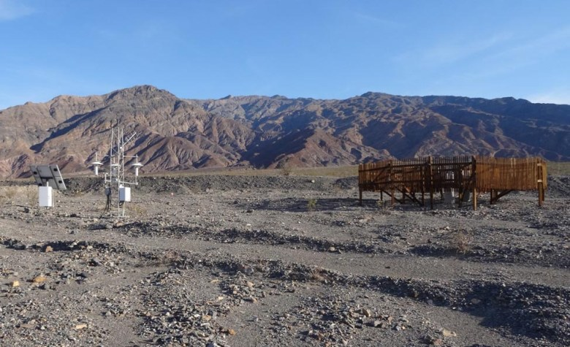Figure 3. The Stovepipe Wells measurement station in Death Valley, California. (Image credit: NOAA)
Highest recorded minimum temperature in North America: 107.7°F
Another astonishing heat record occurred on Sunday, when the 24-hour low temperature at Stovepipe Wells, also located in Death Valley, dropped to a ridiculously hot 107.7 degrees Fahrenheit (42.1°C). The previous North American hottest reliably measured minimum temperature on record was 107 degrees Fahrenheit (41.7°C) at Furnace Creek on July 12, 2012. On Sunday, the high temperature at Stovepipe Wells hit 128.6 degrees Fahrenheit (53.7°C) – one of the hottest U.S. temperatures ever measured. Summing together Sunday’s high and low and dividing by two gives an average temperature for the day of 118.1 degrees Fahrenheit (47.8°C), which is very likely a world record for reliably measured average daily temperature.
According to weather records expert Maximiliano Herrera (@extremetemps), only one location worldwide has recorded a higher overnight minimum temperature than Stovepipe Wells: Oman. The world record for highest 24-hour minimum temperature is 108.7 degrees Fahrenheit (42.6°C) at Qurayyat, Oman, on June 26, 2018. The world record for highest overnight low (12-hour low) is 111.6 degrees Fahrenheit (44.2°C) at Khasab Airport, Oman, on June 17, 2017.
Note that the Western Region Climate Center shows seven daily minimums of 110°F occurred at Death Valley’s Greenland Ranch, primarily in the 1920s. These would be the official hottest minimums on record for the world, presumably. However, in an email, climatologist William Reid said, “Do I believe they are authentic? No. The record provided by the observer is plagued by some of the problems found during the 1913 era at the site”.
Stovepipe Wells, established in 2004, is part of NOAA’s Climate Reference Network, with equipment among the highest quality in the world. The station is located at an elevation of 80 feet (24 m), and is usually 3-5 degrees Fahrenheit cooler than Furnace Creek, which is at -193 feet (-59 m).
Other all-time heat records July 9-11
Among U.S. stations with long periods of record spanning at least 40 years, there were at least 12 sites that tied or exceeded their previous all-time (any day) heat record during the July 9-11 western U.S. heat wave (kudos to Maximiliano Herrera for this list):
July 9:
Grand Junction, CO: 107°F (41.7°C), new record
Tonopah, NV: 104°F (40.0°C), tied
July 10:
St. George, UT: 117°F (47.2°C), ties all-time state record for Utah
Farmington, NM: 106°F (41.1°C), new record
St. Johns, AZ: 104°F (40.0°C), tied
Page, AZ: 111°F (43.9°C), tied
Mercury, NV: 113°F (45.0°C), tied
Toponah, NV: 104°F (40.0°C), tied
Las Vegas Airport, NV: 117°F (47.2°C), tied
China Lake, CA: 119°F (48.3°C), tied
Barstow-Daggett Airport, CA: 118°F (47.8°C), tied
Bishop, CA: 111°F (43.9°C), new record
Winslow, AZ: 110°F (43.3°C), new record
July 11:
Tonopah, NV: 105°F (40.6°C), new record
This list may be updated if additional records come to light, or are set on Monday, when the heat wave will be winding down. Over the past 30 days, according to the NOAA/NCEI database of record highs and lows, the U.S. has racked up a startling total of at least 301 all-time record highs. NOAA’s list includes stations with a period of record shorter than 40 years, though.
Update from July 13: Many more all-time heat records fell July 9-11 in Utah, Arizona, California, Colorado, and Nevada, according to Maximiliano Herrera. In Utah alone, there were these: Eskdale (tied), Kodachrome Basin (tied), Fort Duchesne (tied), Hovenweep 109°F on July 9 (beaten), Escalante 106°F on July 9 (beaten), and Bullfrog Basin 114°F on July 10 (beaten).
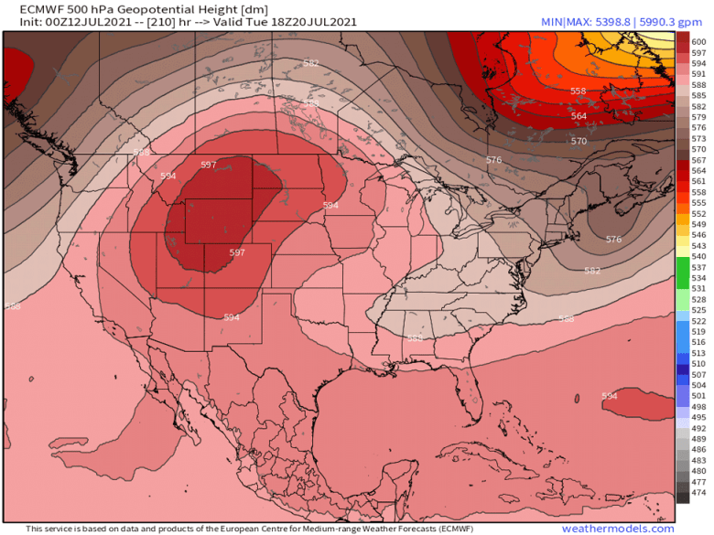Figure 4. Predicted height of the atmosphere’s 500-mb surface in decameters (dm) at 18Z (2 p.m. EDT) Tuesday, July 20, 2021, according to the 0Z Monday, July 12, run of the European model. A near record-strength ridge of high pressure with a 500 mb height peaking at 599 dm was predicted to be centered over Wyoming. (Image credit: weathermodels.com)
Déjà vu: another extreme high-pressure ridge predicted for the western U.S. next week
It’s July, the hottest month of the year in the Northern Hemisphere, and extreme ridges of high pressure forming in July have a good chance of setting all-time heat records. Unfortunately, the latest long-range forecasts from the GFS and European models predict that the western U.S. will have another unusually intense ridge of high pressure capable of overthrowing more all-time U.S. heat records next week.
By one common measure, the 0Z Monday run of the European model is predicting that the heat dome at the center of this upper-level high will be nearly as strong as any ever observed in the region. Warm air expanding at lower levels pushes the height of the 500-millibar surface, roughly at the midpoint of the atmosphere, upward. The model predicted a 500-mb height of 599 decameters over Wyoming on July 20. The record-high 500-millibar height at Riverton, Wyoming, as measured in twice-daily weather-balloon launches (soundings) since 1948, is 605 dm.
But long-range forecasts of this nature are often inaccurate, so the coming heat wave may fall short of setting all-time records. However, the models did an excellent job seven days in advance in predicting the intensity of this past weekend’s extreme ridge of high pressure. Even if the next heat wave falls short of setting all-time records, it will boost the odds of significant wildfire activity, and intensify the record drought gripping the western U.S., where severe to exceptional drought (levels D2 to D4) was at 83% last week – the highest level since the U.S. Drought Monitor was established in 2000.
Kudos to Maximiliano Herrera (@extremetemps), William Reid (stormbruiser.com), Jérôme Reynaud (geoclimat.org), Chris Burt, Bob Henson (@bhensonweather), Howard Rainford, Etienne Kapikian (@EKMEteo), and Thierry Goose (@ThierryGooseBC), for their assistance on this post.
Website visitors can comment on “Eye on the Storm” posts. Please read our Comments Policy prior to posting. Comments are generally open for 30 days from date posted. Sign up to receive email announcements of new postings here. Twitter: @DrJeffMasters and @bhensonweather
TAGGED: Jeff Masters
JEFF MASTERS
Jeff Masters, Ph.D., worked as a hurricane scientist with the NOAA Hurricane Hunters from 1986-1990. After a near-fatal flight into category 5 Hurricane Hugo, he left the Hurricane Hunters to pursue a... More by Jeff Masters
Lesson 2
Example of an article discussing the terms of the typology:
https://www.washingtonpost.com/opinions/2021/10/07/our-planet-is-not-doomed-that-means-we-can-must-act/
Opinion: Our planet is not doomed. That means we can, and must, act.
By Dagomar Degroot
October 7, 2021 at 12:09 p.m. EDT
Dagomar Degroot is an associate professor of environmental history at Georgetown University.
Like most climate scholars, I worry about the future. I know climate change will cause widespread destruction in the coming century. I fear my children may never escape the sense that things are getting worse. They may take for granted that summer comes with smoky skies and deadly heat; that cities need walls against the sea; that deserts expand and ice sheets retreat; that crops need genetic modification; that coral reefs are dead relics of a gentler time.
But does that mean our human future is doomed? Today, many of the most-read publications and most-shared tweets on the climate crisis predict extinction, and a new survey of young people in 10 countries shows that most of them agree. Climate “doomism” holds that greenhouse gas emissions are soaring beyond control, that runaway heating will continue even if emissions decline, and that ecosystems, then societies, will collapse once heating exceeds thresholds that will soon be reached.
It’s a terrifying thought. But it’s wrong — and dangerous.
To explain why, it’s worth repeating a simple truth: The future of climate change depends, first, on human-generated greenhouse gas emissions and, second, on the sensitivity of Earth’s climate to those emissions.
Let’s start with emissions. Owing in large part to the plummeting cost of solar and wind power, they have plateaued, and should soon begin to decline. Scenarios that forecast soaring emissions, considered likely only a few years ago, now seem implausible.
Yet Earth’s sensitivity to those emissions is so high that, if policies and technologies remain as they are, by century’s end Earth will probably warm by close to three degrees Celsius. Warming of this magnitude, with this speed, could strengthen feedback loops in Earth’s environment that cause still more warming. Heat waves would dry up forests, for example, increasing the likelihood of wildfires that release additional carbon dioxide into the atmosphere, causing more warming, more burning, and so on.
But there’s good news. Emissions — not feedbacks — will probably determinethe temperature of the Earth by the end of this century. New research suggests that if we stop releasing more greenhouse gases than environments — and perhaps new technologies — can absorb, the Earth will soon stop warming. How soon would depend on whether we also stop emitting aerosol pollutants and on natural variability in the Earth’s climates. Yet we are not committed to a much hotter future.
“Doomism” also holds that even small changes in average weather have toppled past societies. Some historical societies did indeed suffer when climates changed for natural causes (more modestly than they undoubtedly will this century). Yet the idea of an ideal climate for civilization is based on centuries-old, racist assumptions that only Europe and North America were well suited for human development. Today, research in many fields finds that societies often adapted to past climate changes, and few collapsed. Some societal adaptations were counterintuitive; when land sank relative to sea levels, for example, populations repeatedly gathered near the coast.
In recent years, a new generation of activists has finally forced the climate crisis to the forefront of public debate and legislation. Climate policies have been drafted or are being implemented on a scale that once seemed unimaginable. It is not enough, and large-scale efforts to adapt to climate change are only in their infancy. Yet it is beginning to feel possible that the climate crisis can be overcome.
Doomism threatens to derail this progress. What use is fighting if the battle is already lost? Why advance any righteous cause — racial justice, a fair economy, a healthy democracy — when the climate apocalypse is right around the corner? Doomism encourages apathy — and those who benefit are the very corporations and political extremists most responsible for the environmental and social problems we face.
Doomism may be increasingly popular, but so is its equally implausibleopposite: the belief that economic growth and technological innovation will increase wealth and security more quickly than climate change can diminish them. According to that view, even extreme emissions scenarios are nothing to worry about.
It is an indictment of our media that two extreme scenarios, often propounded by ill-informed ideologues, dominate conversations about the climate crisis. Both discourage action: one because it’s destined to fail, the other because it’s unnecessary.
Yet the most likely future is one that lands between these extremes. In it, emissions decline but not as quickly as they should; warming reaches dangerous highs, but doesn’t overwhelm our capacity for adaptation. It is this future that demands we act urgently. We must cut emissions more quickly than they’re on pace to fall; we must realize our adaptive capacities. The future of the planet, and of humanity, is at stake.
Lesson 3
Read the summary for policy makers of the IPCC Physical Science Basis report 2021 and produce a short paragraph of 10 to 15 lines in English summing up the main points. Summary available at: https://www.ipcc.ch/report/ar6/wg1/downloads/report/IPCC_AR6_WGI_SPM.pdf
Lesson 4
Read UVSQ’s sub-report on climate change scepticism for the ERUM project and take some notes about its principal conclusions.
The sub-report is available at:
https://projects.uni-foundation.eu/erum/wp-content/uploads/sites/2/2020/08/ERUM-IO1-Subreport-UVSQ_final.pdf

Lesson 5
Read the article below from the National Geographic in view of discussing it in class and summing ip up at home thereafter. You can access the piece via this link:
https://www.nationalgeographic.com/environment/article/this-summer-could-change-our-understanding-of-extreme-heat
This summer could change our understanding of extreme heat
The record-smashing Pacific Northwest heat wave suggests that climate change has forced us past a threshold for temperatures.
BYMADELEINE STONE
PUBLISHED JULY 20, 2021
• 7 MIN READ
The heat wave that scorched the Pacific Northwestern United States in late June rewrote the record books in ways that were both shocking and difficult to comprehend. Scientists are unsure how best to explain the temperatures, so extreme compared with what meteorologists expect to see in that typically cool, wet region of the world.
In Seattle, Washington, temperatures hit 108 degrees Fahrenheit, 9 degrees hotter than it’s ever been in steamy Tampa, Florida. Portland, Oregon’s 116°F eclipsed Dallas, Texas’s heat record by 3 degrees. Hundreds of miles north of Portland, the British Columbia village of Lytton set a new temperature record for Canada—a Death Valley-like 121 degrees. The next day, the town was engulfed and largely destroyed by a wildfire.
It’s possible the Pacific Northwest simply experienced a very unlucky combination of weather and climate change. But in recent days, some researchers have begun to consider an alternative explanation: Perhaps climate change has set in motion new, as yet poorly understood, processes that are making heat waves that once seemed statistically impossible far more likely.
More work needs to be done to determine if that hypothesis is correct and if so, what the underlying mechanisms are. But if climate feedbacks beyond the warming of the atmosphere have loaded the meteorological dice in favor of events like the Pacific Northwest heat wave, the consequences for human life could be profound, considering that extreme heat is one of the deadliest forms of extreme weather.
In British Columbia, officials reported nearly 500 “sudden and unexpected deaths” around the time of the heat wave. On Friday, the U.S. Centers for Disease Control reported that from June 25-30, hospitals in the Northwest saw nearly 3,000 heat-related visits.
That’s why the scientists who proposed this idea are racing to find answers.
“All of us are slightly shocked” by the Pacific Northwest heat wave, says Geert Jan van Oldenborgh, an extreme weather and climate researcher at the Royal Netherlands Meteorological Institute who is one of those scientists. “We thought we understood heat waves reasonably well. This shows that our understanding is lacking.”
A 1,000-year heat wave
The immediate explanation for the brutal heat that gripped the Northwest in June was a summertime weather pattern known as a heat dome. Within a heat dome, sunshine warms the surface, causing hot air to rise. Eventually, that rising air encounters high pressure that forces it back toward the ground. As the air sinks, it compresses and heats up even further. This process of rising and sinking is repeated over and over, causing the air inside the heat dome to become hotter and hotter.
At mid-latitudes in the summer, heat domes are “the normal way to get a heat wave,” says van Oldenborgh. And while this heat dome was exceptionally strong for the Pacific Northwest, it wasn’t off-the-charts extreme.
The temperatures within the heat dome were another story.
“I think the word for that is astonishment,” says Michael Wehner, an extreme weather researcher at Lawrence Berkeley National Laboratory, when asked for his reaction to new temperature records. “I don’t think anybody believed it could get so hot there.”
It is well established that climate change is making heat waves hotter and more frequent. But to determine how much of an influence the warming climate had on the Pacific Northwest heat wave, scientists needed to conduct a rigorous statistical analysis known as a weather attribution study.
That’s exactly what Wehner, van Oldenborgh, and about two dozen other extreme weather and climate researchers did. Using a published, peer-reviewed protocol, the researchers combined data from long-term weather stations in Portland, Seattle, and Vancouver along with about 20 climate models to explore how the likelihood and intensity of the heat wave were impacted by climate change.
Their analysis, released online earlier this month, shows that a heat wave of this strength would have been “virtually impossible” without climate change. This was not a surprise. “For heat waves that’s pretty standard nowadays,” van Oldenborgh says.
What was surprising is just how hot this heat wave was compared with anything the region had seen before—about 9°F hotter, averaged across the study area. Even considering global warming, the authors determined that a heat wave of this intensity was at most a 1-in-1,000 year event.
“We said it is virtually impossible without climate change,” Wehner says. “But I would have said beforehand it is virtually impossible with climate change.”
Bad luck, or a new normal?
While the heat wave could have been a disastrously unlucky confluence of weather effects and climate change, van Oldenbergh and his colleagues are now exploring the possibility that atmospheric warming made the event far more likely because of “nonlinear” processes that aren’t being captured by today’s climate models.
What those processes might be is an open question. One possibility, van Oldenbergh says, is that the summertime drought zone centered in the southwestern U.S. is expanding north. This would allow more intense heat waves further north, since places with less soil moisture experience less cooling through evaporation as the sun heats the ground.
However, while much of the Pacific Northwest is very dry right now and this likely had an amplifying effect on the heat wave, the most intense heat extremes occurred in parts of British Columbia that received ample rainfall in June. The role of drought “is not clear cut,” van Oldenbergh says. “There are a lot of details that don’t fit the hypothesis.”
Climate change could also be impacting the jet stream in ways that make extreme summer heat waves more likely. A recent modeling paper found that as global warming progresses, heat waves will become more persistent over North America and elsewhere —perhaps due to a more sluggish jet stream that could slow down weather systems. Slower moving heat waves can dry out soils and vegetation more, exacerbating the effects of drought.
This jet stream connection is still a matter of scientific debate, and tying atmospheric circulation changes to any one event like the Pacific Northwest heat wave will be very difficult, says Kai Kornhuber, a postdoctoral researcher at the Columbia University Earth Institute who led the recent modeling study.
“In the long run, a weakened [jet stream] circulation will lead to more persistent summer heat waves,” Kornhuber says. “So in that sense, it’s in line with that expected outcome, but it’s really hard to attribute a certain fraction.”
Various authors on the recent attribution study will be exploring different hypotheses in the weeks and months to come. That includes seeing if the Pacific Northwest heat wave was “compatible with bad luck,” van Oldenbergh says. “You can do that by looking at all the [biggest] heat waves throughout the world and making a statistics distribution.”
Whether or not the recent heat wave was a sign that human carbon emissions have tipped off new heat-amplifying processes in the atmosphere, the severity of the event should be a wake-up call about the climate we’re creating, says Jessica Tierney, a paleoclimatologist at the University of Arizona.
“Knowing what we know about how much warmer the Earth system can get, the fact that we’re seeing these severe events and we’ve only warmed a little over a degree is scary,” Tierney says. “If it’s this bad already, do we really want to go to 3 or 4 degrees above pre-industrial?”

