The Impact of Climate Change in the Arctic
mODULE DESCRIPTION AND GUIDELINES FOR THE INSTRUCTOR
Lesson 1
Where is the Arctic – The Arctic Portal:
https://portlets.arcticportal.org/where-is-the-arctic
Although anybody may point where the Arctic is, that is to say, that portion of sea and land surrounding the North Pole or, in more in general, that northernmost portion of the Northern hemisphere, “there is nothing intuitively obvious about the idea of treating the Arctic as a distinct region” (Arctic Human Development Report I). In fact, the definition of the Arctic has represented and yet represents an issue per se, and yet no single, clear cut boundary currently exists. Rather, the definition of Arctic very much depends on the features highlighted.
The word “Arctic” derives from the ancient Greek, arktikos, literally meaning “of the Bear ”, referring to either the Ursa Major either the “Ursa Minor” constellation, in any case, an idea pointing the geographical North. For centuries, the Arctic was vaguely considered as the northernmost lands and waters of the northern hemisphere, with no clear knowledge of it. In fact, even if the Arctic regions have been inhibited for millennia by indigenous populations (for example, the earliest known cultures in Greenland, the Saqqaq culture, is dated 2500-800 BC), Western societies had little knowledge of, and interest in, the area, until very recent times. Knowledge of the area has been a slow and progressive process started centuries ago, and yet not fully accomplished, as described for instance by the Icelandic President Ólafur Ragnar Grímsson’s famous quote “we know more about the moon than the Arctic”.
In contemporary times, the Arctic region has been primarily defined as this portion of land and water above the parallel 66° 33’’ 44’’ North, that is to say, the “Arctic Circle”. This imaginary line circling the globe marks the latitude above which, in theory, the sun never sets on the summer solstice, June 21st and never rises on the Winter Solstice, December 21st. However, due to refraction and other physical effects, the “midnight sun” may be seen also at lower latitudes.
Understandably, the portion of the globe described by the Arctic Circle does not follow any specific criteria, separating contiguous areas potentially homogenous. Indeed, additional biophysical and other criteria have been progressively outlined to encompass a more homogenous region surrounding the North Pole.
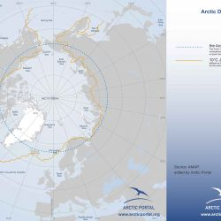10C July Isotherm (map: Arctic Portal)
Among these biophysical criteria still in use, is the 10° July isotherms, defined as being the area where the average temperature in the warmest month (July) is below 10ºC / 50ºF.
Another criteria in use, for instance, is the tree-line. The tree line or timberline is the edge of the habitat at which trees are capable of growing. Beyond the tree line, they are unable to grow because of inappropriate environmental conditions (usually cold temperatures, insufficient air pressure, or lack of moisture). At the tree line, tree growth is often very stunted, with the last trees forming low, densely matted bushes. If it is caused by wind, it is known as krummholz formation, from the German for 'twisted wood'. The tree line, like many other natural lines (lake boundaries, for example), appears well-defined from a distance, but upon sufficiently close inspection, it is a gradual transition. Trees grow shorter towards the inhospitable climate until they simply stop growing. Extremely cold temperatures can result in freezing of the internal sap of trees. In addition, permafrost in the soil can prevent trees from getting their roots deep enough for the necessary structural support. Because the climatic zone in which the high-latitude timberline occurs is almost entirely under water in the Southern Hemisphere, this timberline exists only in the Northern Hemisphere. It crosses northern Siberia, Alaska, and Canada, and far-northern Scandinavia.
The above definitions based on biophysical criteria, while defining a portion of territory with very homogenous physical characteristic, have turn out to be unsuitable in defining a region under common economic, political and social features.
As the geopolitical relevance of the Arctic has been constantly growing over the last few decades, so has the interest in defining its borders. However must be bear in mind, as stated above, that “when defining Arctic regions, it is understood that no single, clear cut boundary exists to delineate their extent. Rather, this boundary will change with its application: environmental, biological, economic, jurisdictional, or social”(Grid-Arendal).
An extensive work aimed at better outlining an economically/socially/politically homogenous region to be called “Arctic” has been initiated during the late 90’s by the Arctic Council Working Groups, which were in need to define the boundaries of their mandate. In fact, although the Arctic Council counts of 8 Arctic States Members (Canada, USA, Iceland, Kingdom of Denmark, Sweden, Norway, Finland and Russia), not the whole territory of these countries can be considered as Arctic.
The Arctic Monitoring and Assessment Program (AMAP) has first defined a regional extent based on a compromise among various definitions:

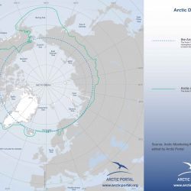Arctic AMAP boundary (map: Arctic Portal)AMAP
"Given the different definitions of the Arctic, based on physical-geographical characteristics as described above, and those based on political and administrative considerations within different countries, no simple delineation of the Arctic region was applicable for the purposes of the AMAP assessment. To establish a geographical context for the AMAP assessment, therefore, a regional extent was defined based on a compromise among various definitions. This incorporates elements of the Arctic Circle, political boundaries, vegetation boundaries, permafrost limits, and major oceanographic features. The region covered by AMAP is, therefore, essentially the terrestrial and marine areas north of the Arctic Circle (66°32'N), and north of 62°N in Asia and 60°N in North America, modified to include the marine areas north of the Aleutian chain, Hudson Bay, and parts of the North Atlantic Ocean including the Labrador Sea. As stated above, the AMAP boundary was established to provide a geographical context for the assessment, in particular source-related assessment issues, i.e., consideration of sources within and outside the Arctic. The relevance of the AMAP boundary varies when considering different issues, and it has therefore been applied accordingly. Thus, contaminant levels in biota are addressed in relation to the geographical occurrence of the species concerned; demographic data are discussed in relation to administrative regions on which, for example, census data are collected.
(AMAPs 1998 assessment report, pg. 10)

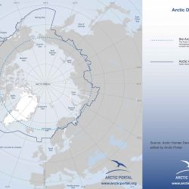AHDR Arctic Boundary (map: Arctic Portal) Arctic Human Development Report (I and II)
The Arctic boundaries as defined by AMAP have been the ground for several following well-known definitions, as for instance the Arctic Human Development Report I and II, one of the most used definition nowadays: “For this reason, the AHDR takes as its point of departure the region that the Arctic Monitoring and Assessment Programme covers in its 1997 and 2002 reports (4-5). For reasons having to do mainly with the location of jurisdictional or administrative boundaries and the availability of data, however, the area covered by this report differs from the AMAP Arctic in some respects”.
The AHDR’s definition embraces a rather homogenous cultural, social and economic region, considering the Arctic that area of 4o million km2, that “encompasses all of Alaska, Canada North of 60°N together with northern Quebec and Labrador, all of Greenland, the Faroe Islands, and Iceland, and the northernmost counties of Norway, Sweden and Finland. The situation in Russia is harder to describe in simple terms as demarcated by our demographers, encompasses
the, a Murmansk Oblast, the Nenets, YamaloNenets, Taimyr, and Chukotka autonomus okrugs, Vorkuta City in the Komi Republic, Norilsk and Igsrka in Krasnoyarsky Kray, and those parts of the Sakha Republic whose boundaries lie closest to the Arctic Circle”.

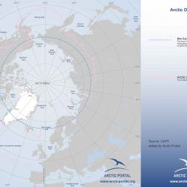CAFF boundary (map: Arctic Portal) CAFF
Other, as the Conservation of Arctic Flora and Fauna (CAFF), another AC Working Group, has developed their own boundaries, which are defined as much by political boundaries as by climatic and biological zoning, and“ largely follows the treeline in order to include the ecosystems that are the focus of its activities”(Although the Arctic Biodiversity Reports follows “a more scientific definition of the Arctic”, that is to say, the Circumpolar Arctic Vegetation Map’s (CAVM Team 2003) definition of the Arctic).

The British Museumn blog:
https://blog.britishmuseum.org/an-introduction-to-the-arctic/

An introduction to the Arctic
You might have a picture in your mind of the Arctic – with its vast icy landscapes and plentiful wildlife – but where actually is the Arctic and what cultures live there? Amber Lincoln, curator of the forthcoming Citi exhibition Arctic: culture and climate, reveals what life is like in the most northerly place in the world.
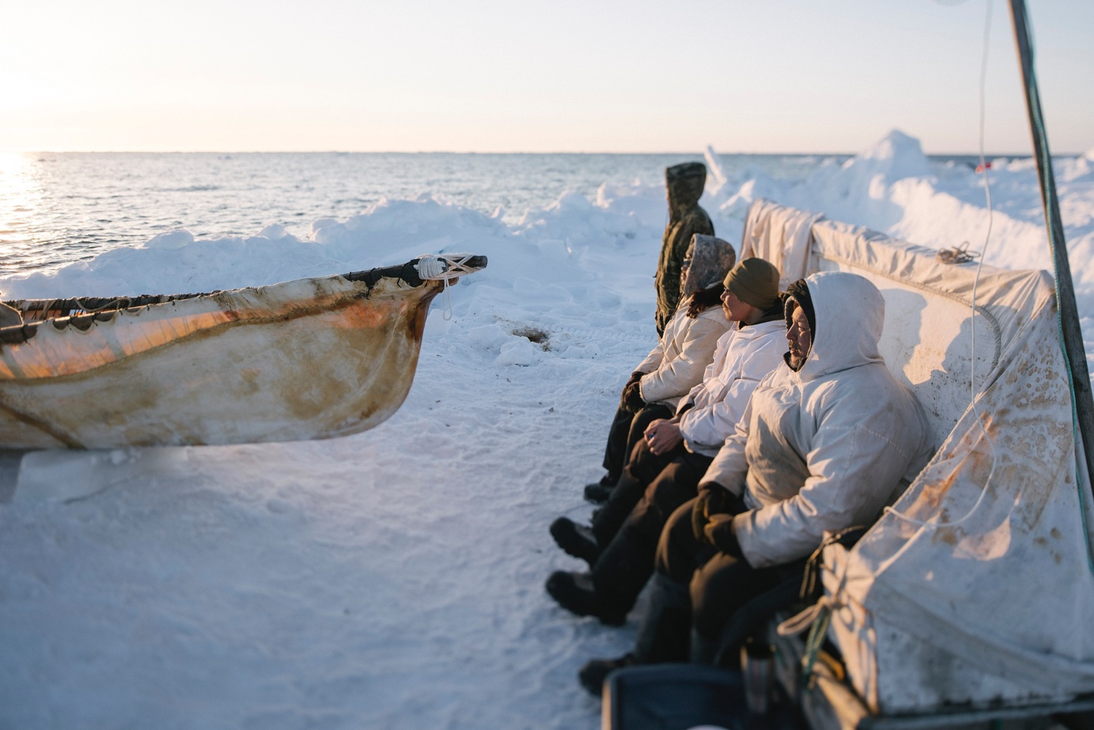
Kiliii Yuyan (b. 1979), 'Whaling Crew on Watch at Amuaq,' Archival inkjet print, 2018 © Kiliii Yuyan.
Amber Lincoln, curator, the Citi exhibition Arctic: culture and climate 9 January 2020

The Arctic captures the imagination, calling to mind a pristine, empty, icy world that in many ways stands still: frozen and timeless. This romantic idea is appealing but of course false. You only have to read the news to know that today the Arctic isn’t standing still. Reporting on scientific studies and assessments by the United Nations’ Intergovernmental Panel on Climate Change (IPCC), helps us all understand how quickly the Arctic is changing as a result of global climate change. Temperatures are rising, altering weather patterns, sea ice is shrinking, raising global sea levels, and permafrost, the once permanently frozen ground that served as bedrock, is melting and sinking. These changes are dramatic and unlike any experienced in the Arctic before, but the truth is, the Arctic never has stood still, nor have its Indigenous People.

Where is the Arctic?
The Arctic is the most northern place on earth and covers 4% of its surface. Its centre, the North Pole, rests over the Arctic ocean, which until recently has been covered by relatively stable, year-round sea ice. The Arctic Circle designates both the southern boundary of the Arctic and the latitude (66.5° North) at which the sun remains above, or below, the horizon for 24 hours, at least one day per year. The further north you go, sunlight is gained or lost at greater speed.
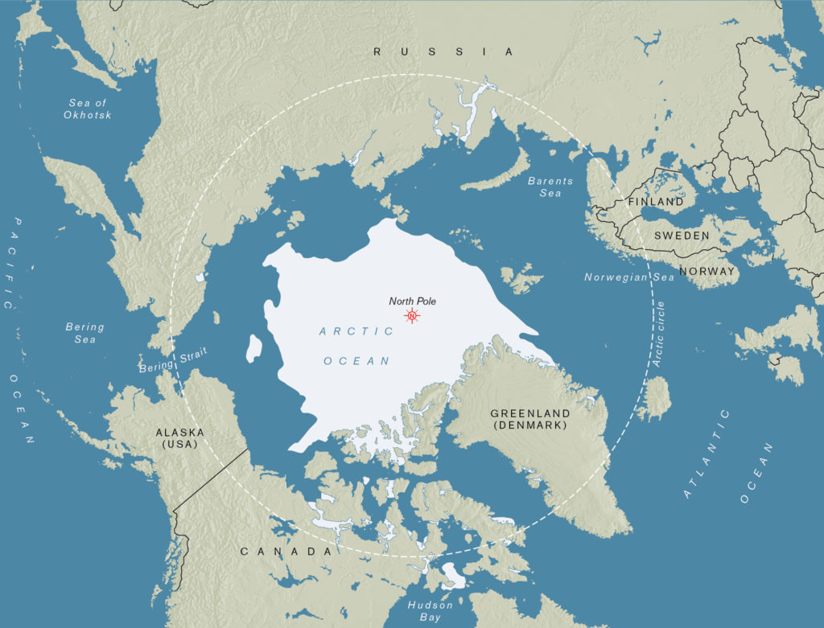
In general, Arctic winters are dark. Moonlight reflecting off snow and ice generates light but life adjusts to the dim. Summers are full of light and people full of energy. However, the intense sunlight reflecting off snow or ice in spring can be very harmful and cause blindness, so Arctic Peoples have made spectacles to protect their eyes. These 19th-century Dolgan examples from north-central Siberia were made from pierced metal and beads embroidered onto reindeer hide. Today, Arctic Peoples use hats and sunglasses, but these historic models elegantly protected the eyes, focused the vision, and helped communicate identity through their different styles.
Man’s snow-spectacles, Dolgan, Yenisei (Russia). Reindeer skin, metal, glass beads, uranium beads. Pre-1879.

Are there seasons in the Arctic?
The seasonal behavior of light helps eliminate another false idea about the Arctic – that it is always frozen and barren. Certainly, winter months are dark and cold, temperatures commonly reach -40° C and many animals migrate south. But these lean seasons alternate with periods of extraordinary abundance in the summer, when continental temperatures in areas such as north-central Siberia or the Northwest Territories, Canada, can reach 30–35°C. The continuous daylight in summer generates algae blooms in sea ice habitats, forming the base of the food chain for masses of migrating sea mammals and birds. Local plants and fungi spring to life with berries, greens and mushrooms, supporting reindeer, caribou and other land animals. Arctic Peoples thrive by harnessing the great concentrations of animals and plants during abundant times to carry them through lean stretches.
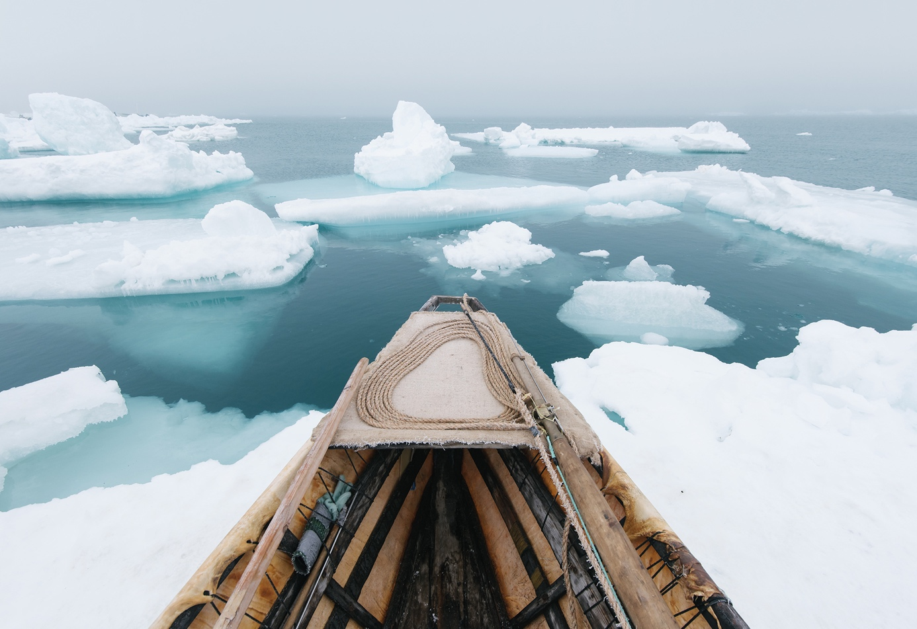Kiliii Yuyan (b. 1979), Umiaq and north wind during spring whaling. Inkjet print, 2019. © Kiliii Yuyan.

Who lives in the Arctic?
Today, four million people live in the Arctic. They are spread across the eight countries with territory in the Arctic: Russia, USA, Canada, Denmark/Greenland, Iceland, Norway, Sweden and Finland. Only 10% (400,000) of those Arctic inhabitants are indigenous to the region, belonging to one or more of the 40 different cultural groups. The Sámi are the only Indigenous Arctic Peoples in northern Europe, occupying parts of Norway, Sweden, Finland and north-west Russia. There are many different groups in north-west Russia and northern Siberia. The Nenets, Mansi and Khanty, and Nganasan originate in north-west Russia. The Evenki, Even, Sakha, and Dolgan are from north-central Siberia. The Yukaghir, Koryak, Chukchi, and Siberian Yupik occupy the Russian Far East. Indigenous People in North America include the Aleuts, Alutiit, Yupiit, and Inupiat of Alaska, the Gwich’in bordering Alaska and Canada, and Inuit groups of Canada and Greenland.
Kiliii Yuyan (b. 1979), Whaling Crew on Watch at Amuaq. Archival inkjet print, 2018. © Kiliii Yuyan.
These Indigenous Arctic Peoples have traded and engaged with each other for millennia. Today they collaborate in international organisations such as the Arctic Council and the Inuit Circumpolar Council. The Inuit are a unified indigenous group, sharing a common language, culture and history, who live within four countries: Chukotka, Chukotka (Russia), Alaska (USA), Canada, Greenland (Denmark). In Canada and Greenland, the term ‘Eskimo’ is considered derogatory because it was a name given by non-Inuit people and thought to mean ‘eater of raw meat’. Linguists now believe ‘Eskimo’ was a term used by the Ojibwe (Indigenous People from Canada and North America) for Inuit meaning ‘to net snowshoes’. Nonetheless, Inuit is the name they use to describe themselves. Eskimo is more commonly used in Alaska to collectively refer to all Inuit and Yupiit. This is because ‘Inuit’ is not a word in the Yupiit languages of Siberia and Alaska.

How long have people lived in the Arctic?
The Arctic has been occupied for a very long time and the cultures are remarkably old. When much of Europe was covered in glaciers, the steppe (or plains) of northeastern Siberia was glacier free and it was possible to settle. Recent archaeological findings show that Paleolithic hunters occupied the mouth of the Yana River of north eastern Siberia 30,000 years ago. Inhabitants hunted woolly mammoth and other megafauna (large animals such as woolly rhinoceros, giant horse and some species of bison that are now extinct) and they developed the first Arctic art. The ancient people of Yana (in north eastern Siberia) spent a lot of time making jewellery, adorning themselves with animal-teeth pendants and beads made from mammoth tusks, hare bones or rare minerals. They also made bracelets engraved with detailed marks indicating personal or community identity. The earliest Arctic inhabitants led rich lives, created a cultural aesthetic and used resources available to them in innovative ways.
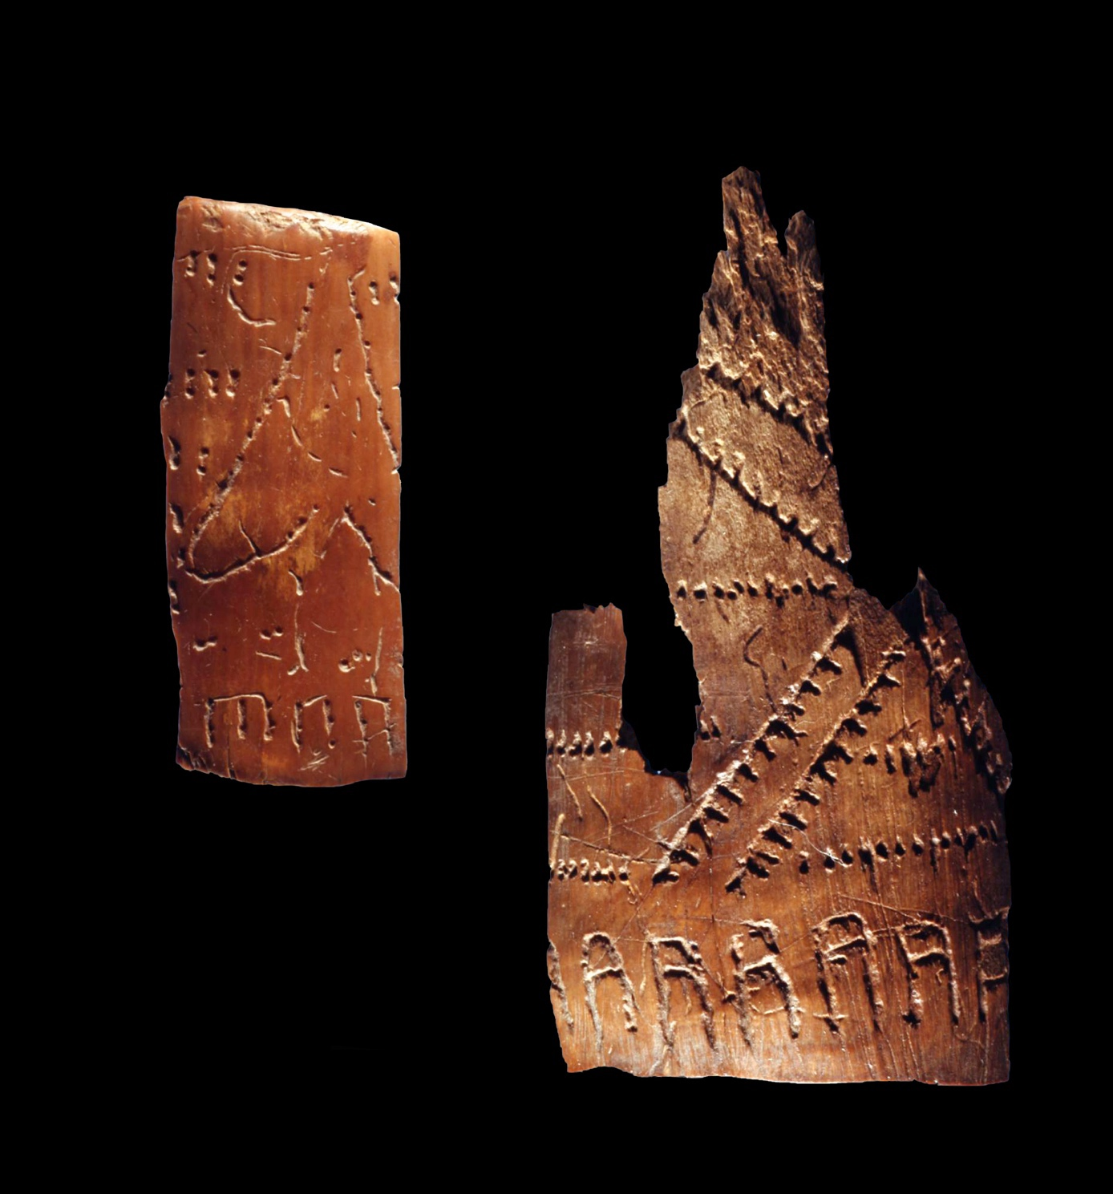Walrus ivory bracelet, Yana-site, Russia, c. 28,000–26,000 BC. Institute for the History of Material Culture, Russian Academy of Sciences © Pavel Ivanov, Elena Pavlova, Vladimir Pitulko.

How do Arctic people keep warm?
Warm clothing that enables mobility is essential for life in the Arctic. This Inuit hunting outfit made from caribou fur from Baffin Island, Nunavut, was made in 1987. It kept the wearer warm while traveling by sled or snowmobile in the winter. But clothing serves multiple functions.
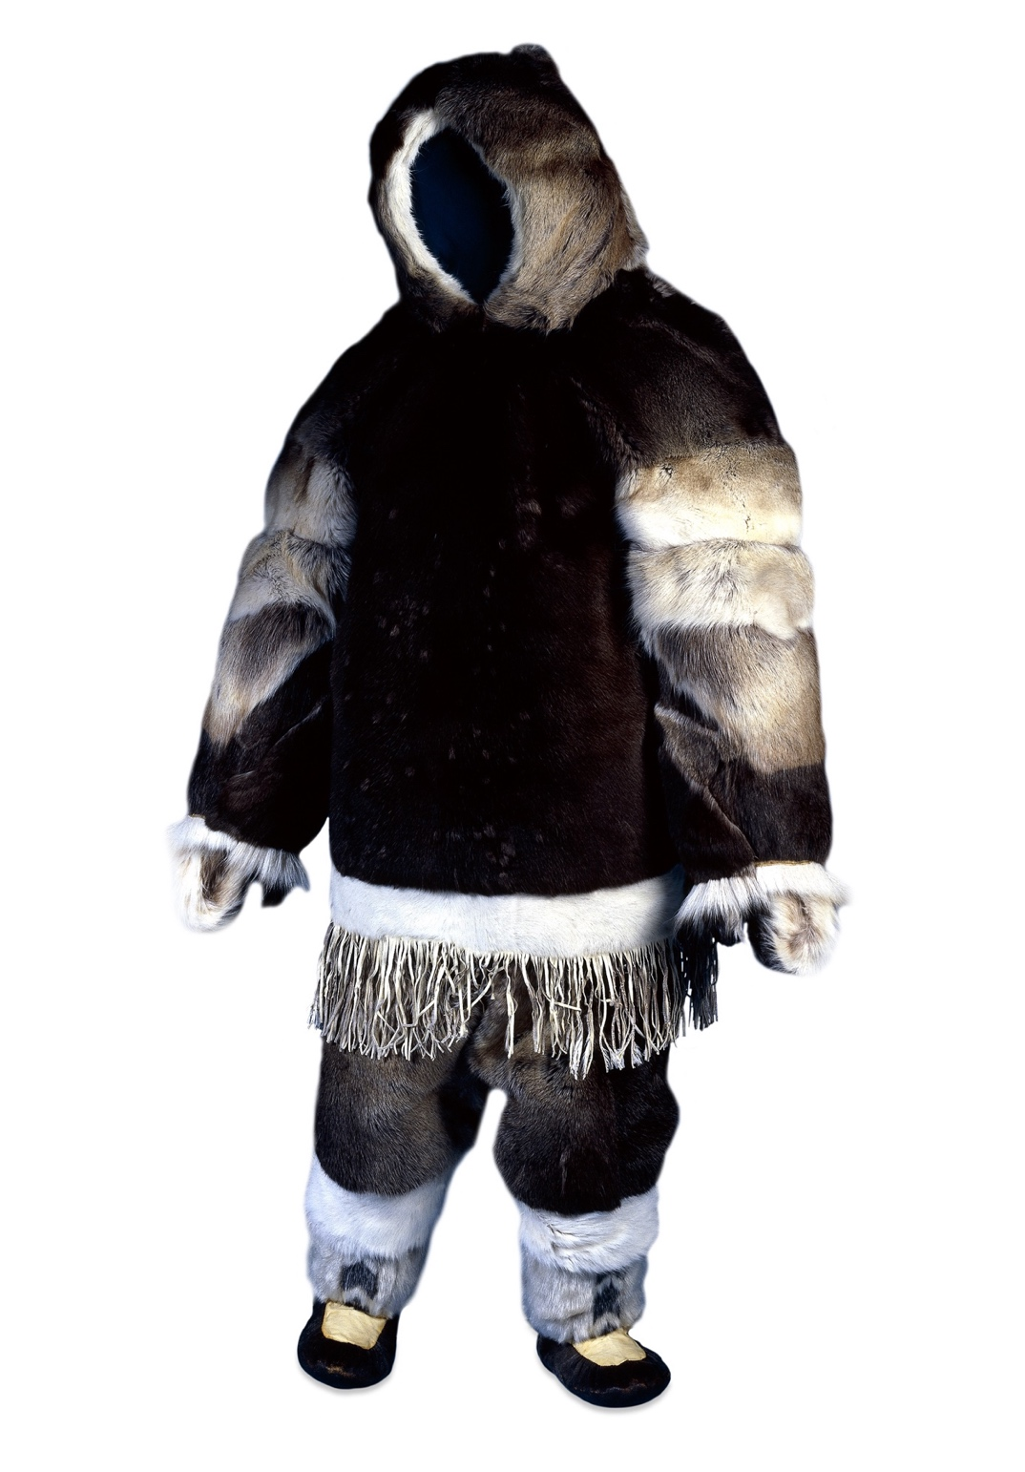
Man’s winter parka. Inuit, Iglulik (Nunavut). Caribou skin, sinew and polar bear fur,
1950–1985.
Sámi garments often communicate identity and belonging. This Sámi women’s hat, called Ládjogahpir, or ‘foremother’s horn hats’, was made with a piece of wood called fierra. It identified the wearer as a Sámi woman of Norway. These hats fell out of use around 1870 after missionaries, who interpreted the horn as representing the devil, considered them sinful. Today, hats in the style of the Ládjogahpir have taken on a new identity. Amid wider Sámi revitalisation movements, Sámi women have started making and wearing the ládjogahpir again as colonial resistance art.
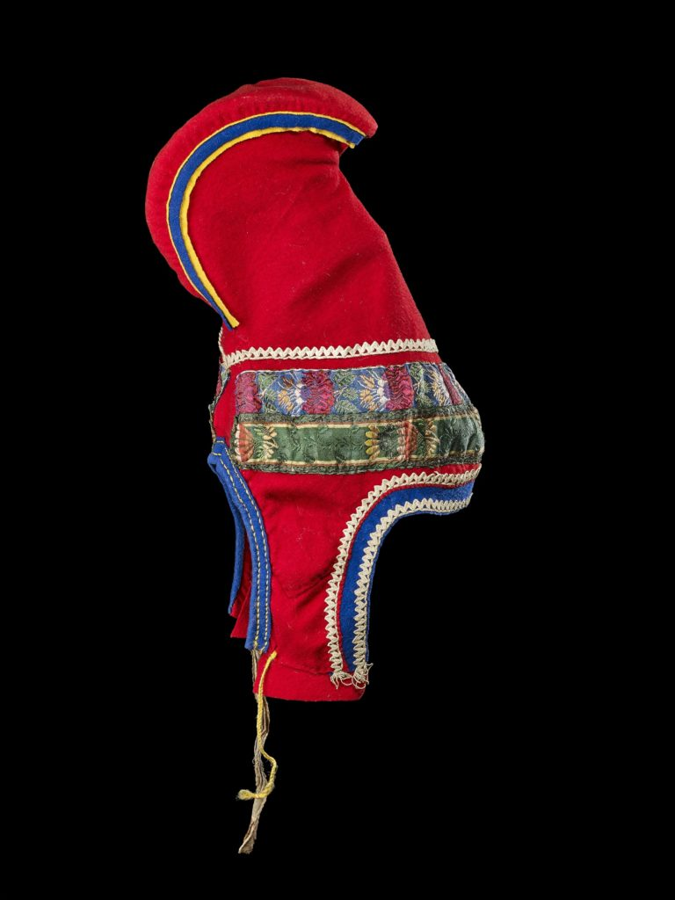Woman’s hat or ládjogahpir, Sámi, Norway. Wool, horn, cotton and silk, pre-1919.

How do people make a living in the Arctic?
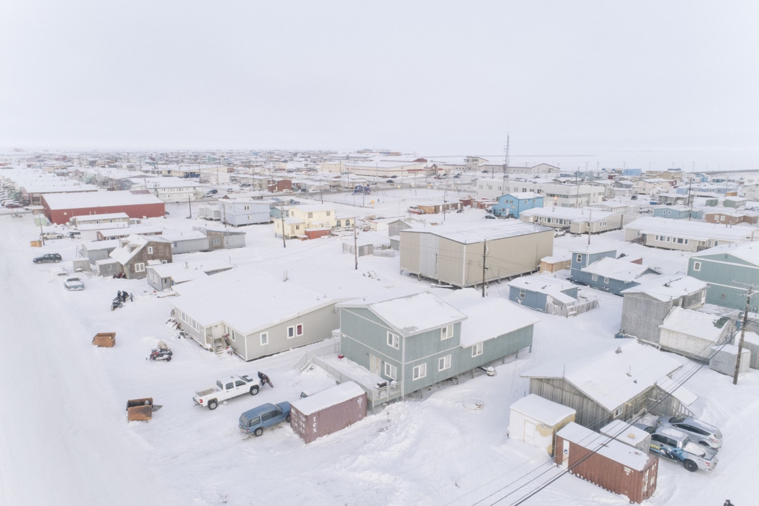Utqiagvik, ones of the largest cities in the US state of Alaska. Kiliii Yuyan (b. 1979), Utqiagvik at Twilight. Archival inkjet print, 2017. © Kiliii Yuyan.
Today Arctic Peoples are fully participating global citizens, engaging in all sorts of markets and industries. Many Arctic Peoples live in southern or Arctic cities, working various jobs including in the oil and gas industries, tourism and commercial fishing. Others pursue education. Some Arctic Peoples live in smaller settlements, within or near their ancestral homelands, engaging in more traditional economies. Because the Arctic does not support agriculture, in the past, Arctic Peoples have relied upon animals. Diets and livelihoods were dependent on hunting, fishing, trapping and reindeer herding. Many Arctic Peoples today continue to pursue these ways of life, maintaining close links with their homelands and traditional cuisine. Some reindeer herders, such as the Nenets of north central Russia, travel seasonally with their migrating herds of reindeer. Similarly, hunters or fishers might make journeys from their villages to hunting grounds, by crossing land or sea ice.
Harpoon-head. Yupiit; Kuskokwim. Ivory, brass, and seal or walrus skin, pre-1900.
One piece of adaptive technology used to hunt seals, as well as whales and walrus, is still used today. As year-round inhabitants of the Arctic, seals provide crucial nutrients and materials for Inuit. The toggle-head harpoon is an ingenious hunting tool because it prevents hunters from losing their prey to the sea. They were often beautifully engraved, like this late 19thh-century Yupiit model, in order to attract animals and show them respect. Harpoon heads were fitted into shafts and thrown by hunters. The toggle-head swivelled upon entering the animal’s skin so it couldn’t easily exit the wound hole. Attached to a line, hunters could easily retrieve harpooned animals and avoid wounding and losing one.
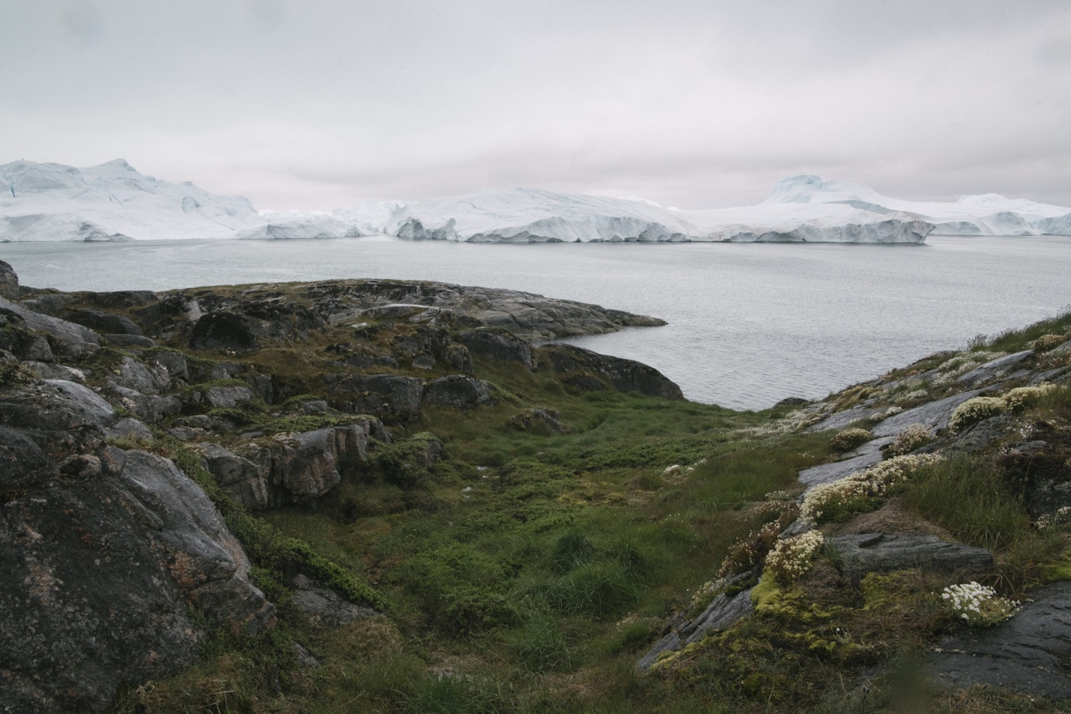Tundra in Ilulisaat, Greenland.
Kiliii Yuyan (b. 1979), Ilulisaat’s Living Ice Fjord. Archival inkjet print, 2018. © Kiliii Yuyan.
In addition to hunting and fishing, Arctic Peoples in Asia and Europe herded reindeer. Herders tailored their pastoral practice to the ecosystems of the Arctic. The tundra is generally located near the coast at very high latitudes. No trees grow in the tundra but lichen, which reindeer eat, grows in huge quantities. The unobstructed views and open landscapes enable herders to keep very large herds. Migrating with hundreds or even thousands of reindeer, the Nenets, Chukchi and some Sámi groups travel hundreds of kilometres across the tundra each year to winter and summer rangeland (open country for grazing or hunting animals).
Reindeer harness, Evenki, Yenisei (Russia). Reindeer skin, cotton, glass beads, ivory, wood and metal, 1840s–1870s.
Taiga (referred to as the Boreal forest in North America) has small, but in some places, thick tree growth. Trees of the taiga offer herders less visibility and more obstructions, therefore herders keep fewer animals and focus on riding and packing their reindeer. Rather than using sleds, which can get entangled in the branches of the forest, the Evenki use bags of reindeer hide to store their equipment and food while traveling or hunting. Both Evenki men and women ride special reindeer that are trained to manoeuvre through the taiga. This women’s reindeer saddle, made from white reindeer fur and wood, provides both the rider and reindeer comfort. Reflecting their value to herders, reindeer often are often made beautifully decorated harnesses, pack saddles and other tack, such as this Dolgan beaded harness.
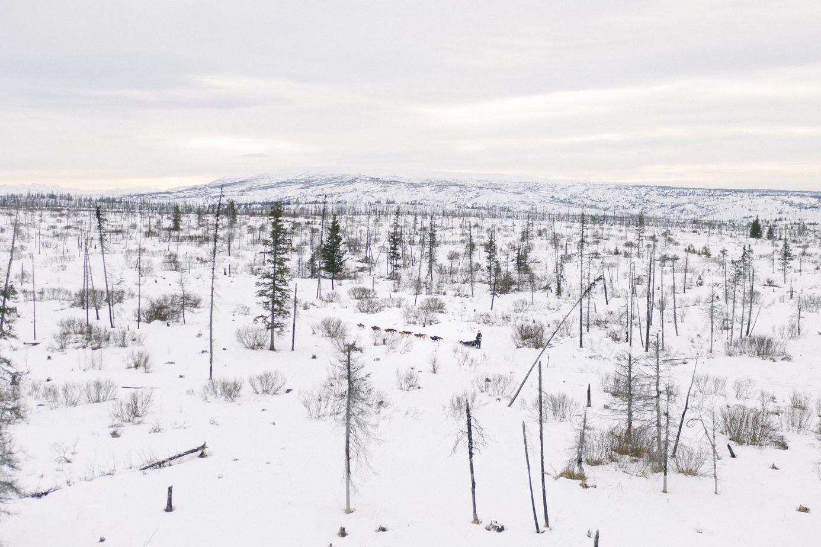Taiga or Boreal forest.
Kiliii Yuyan (b. 1979), Boreal Forest Dash. Archival inkjet print, 2019. © Kiliii Yuyan.
These traditional livelihoods remain important today for the nutritional and material products they provide families and communities but also for their role in asserting cultural identity. Today, Arctic Peoples creatively blend modern and traditional ways of life in practical responses to their needs.
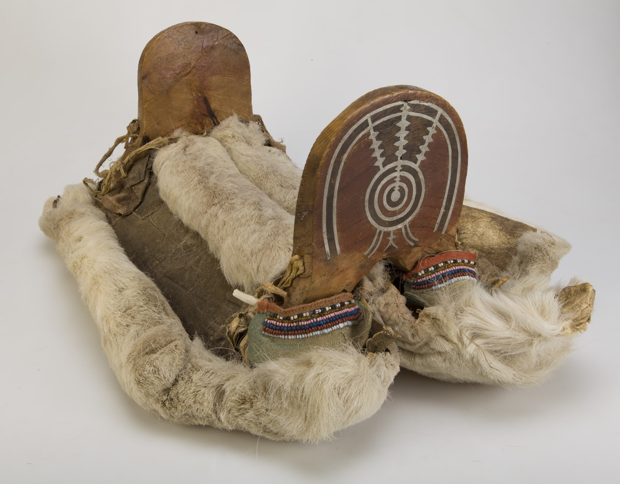Woman’s reindeer saddle. Dolgan, Krasnoyarsk Krai (Russia). Reindeer skin, wood, cloth, and beads, 1890s–1920s. Peter the Great Museum of Anthropology and Ethnography (Kunstkamera) of Russian Academy of Sciences. © MAE RAS (Kunstkamera).

How is global climate change affecting people in the Arctic?
As the ice melts because of rising global temperatures, Arctic Peoples face very real challenges. Arctic communities are vulnerable to erratic storms and freeze/thaws conditions, eroding coastlines, melting permafrost and rising sea levels. In response, Indigenous Arctic organisations are advocating globally about these challenges. Collaborating with researchers, and national and international agencies, Indigenous Arctic organisations are pushing for innovative solutions to develop plans for action to sea level rise and sea ice loss. Through organisations like the Inuit Circumpolar Council, the Arctic Council, and the Sámi Council, elders, leaders and young people advocate for measures to search for answers to the most challenging problem of the 21st century, serving as exemplars of how to remain unified in a rapidly changing world.

Lesson 2
AMAP Climate Change Update report 2021:
https://oaarchive.arctic-council.org/handle/11374/2621
Lesson 3
Resources in the Arctic, map provided by Nordregio, available at: https://nordregio.org/maps/resources-in-the-arctic-2019/

Resources in the Arctic 2019
This map shows both existing and potential sites of mineral and energy resources in the Arctic.
The map shows the main sites for gas and oil activities and mining resources in the Arctic. Exploration, development of production, and transport facilities for oil, gas, and mineral resources is increasing throughout the circumpolar region. Receding sea ice cover and permafrost thaw will influence accessibility to mineral and energy resources both on land and in the Continental Shelf in the future.
Location of petroleum fields
The main onshore and offshore oil and gas deposits in the Arctic are shown on this map. Information on the type of deposit and resource comes from several sources[1]. The main regions in the Arctic linked to oil and gas exploitation are the Beaufort Sea (North Slope, Alaska and Mackenzie Delta, Canada), and the northwest part of the Russian Arctic (Barents Sea and West-Siberia). Oil and gas are also found in the Canadian Arctic Archipelago (Nunavut). These three regions are also targeted for future exploitation. According to estimates from the US Geological Survey, the area north of the Arctic Circle is expected to store recoverable reserves of 90 billion barrels of oil, 1670 trillion cubic feet of natural gas, and 44 billion barrels of natural gas liquids (blue/purple areas on the map). These resources account for about 22% of the undiscovered, technically recoverable resources in the world. About 84% of the estimated resources are expected to occur offshore.
Location of mining sites
Several metallic and non-metallic minerals as well as and coal resources can be found in the Arctic. The exploitation of these resources is not a recent phenomenon, however due to technical development and decreasing permafrost and sea ice extends these resources are becoming more accessible. The largest metallic and non-metallic mineral and coal mines in the Arctic are shown as grey squares on the map. We used the Mineral Resources Data System by the USGS[2] and several other data sources to show balanced and up-to-date distribution of mining sites across the Arctic. The main areas for mining activities are the Fennoscandian shield with rich metallic and non-metallic mineral resources, as well as the Pechora coal basin in the Russian Federation.
Access to resources
The exploitation and development of the Arctic resources is dependent on the global supply and demand, global market prices, and political agreements. However, the future of Arctic resource extraction is also highly dependent on technical capacities and environmental challenges, which lead to higher extraction costs. Increased transportation, e.g. by tankers, will also require new capabilities to Search and Rescue capabilities as well as oil spill prevention. High economic costs of exploitation and transportation, and high demand for environmental protection are decisive factors for the exploitation of Arctic resources.

[1] Company homepages and national energy strategies
[2] https://mrdata.usgs.gov/mrds/
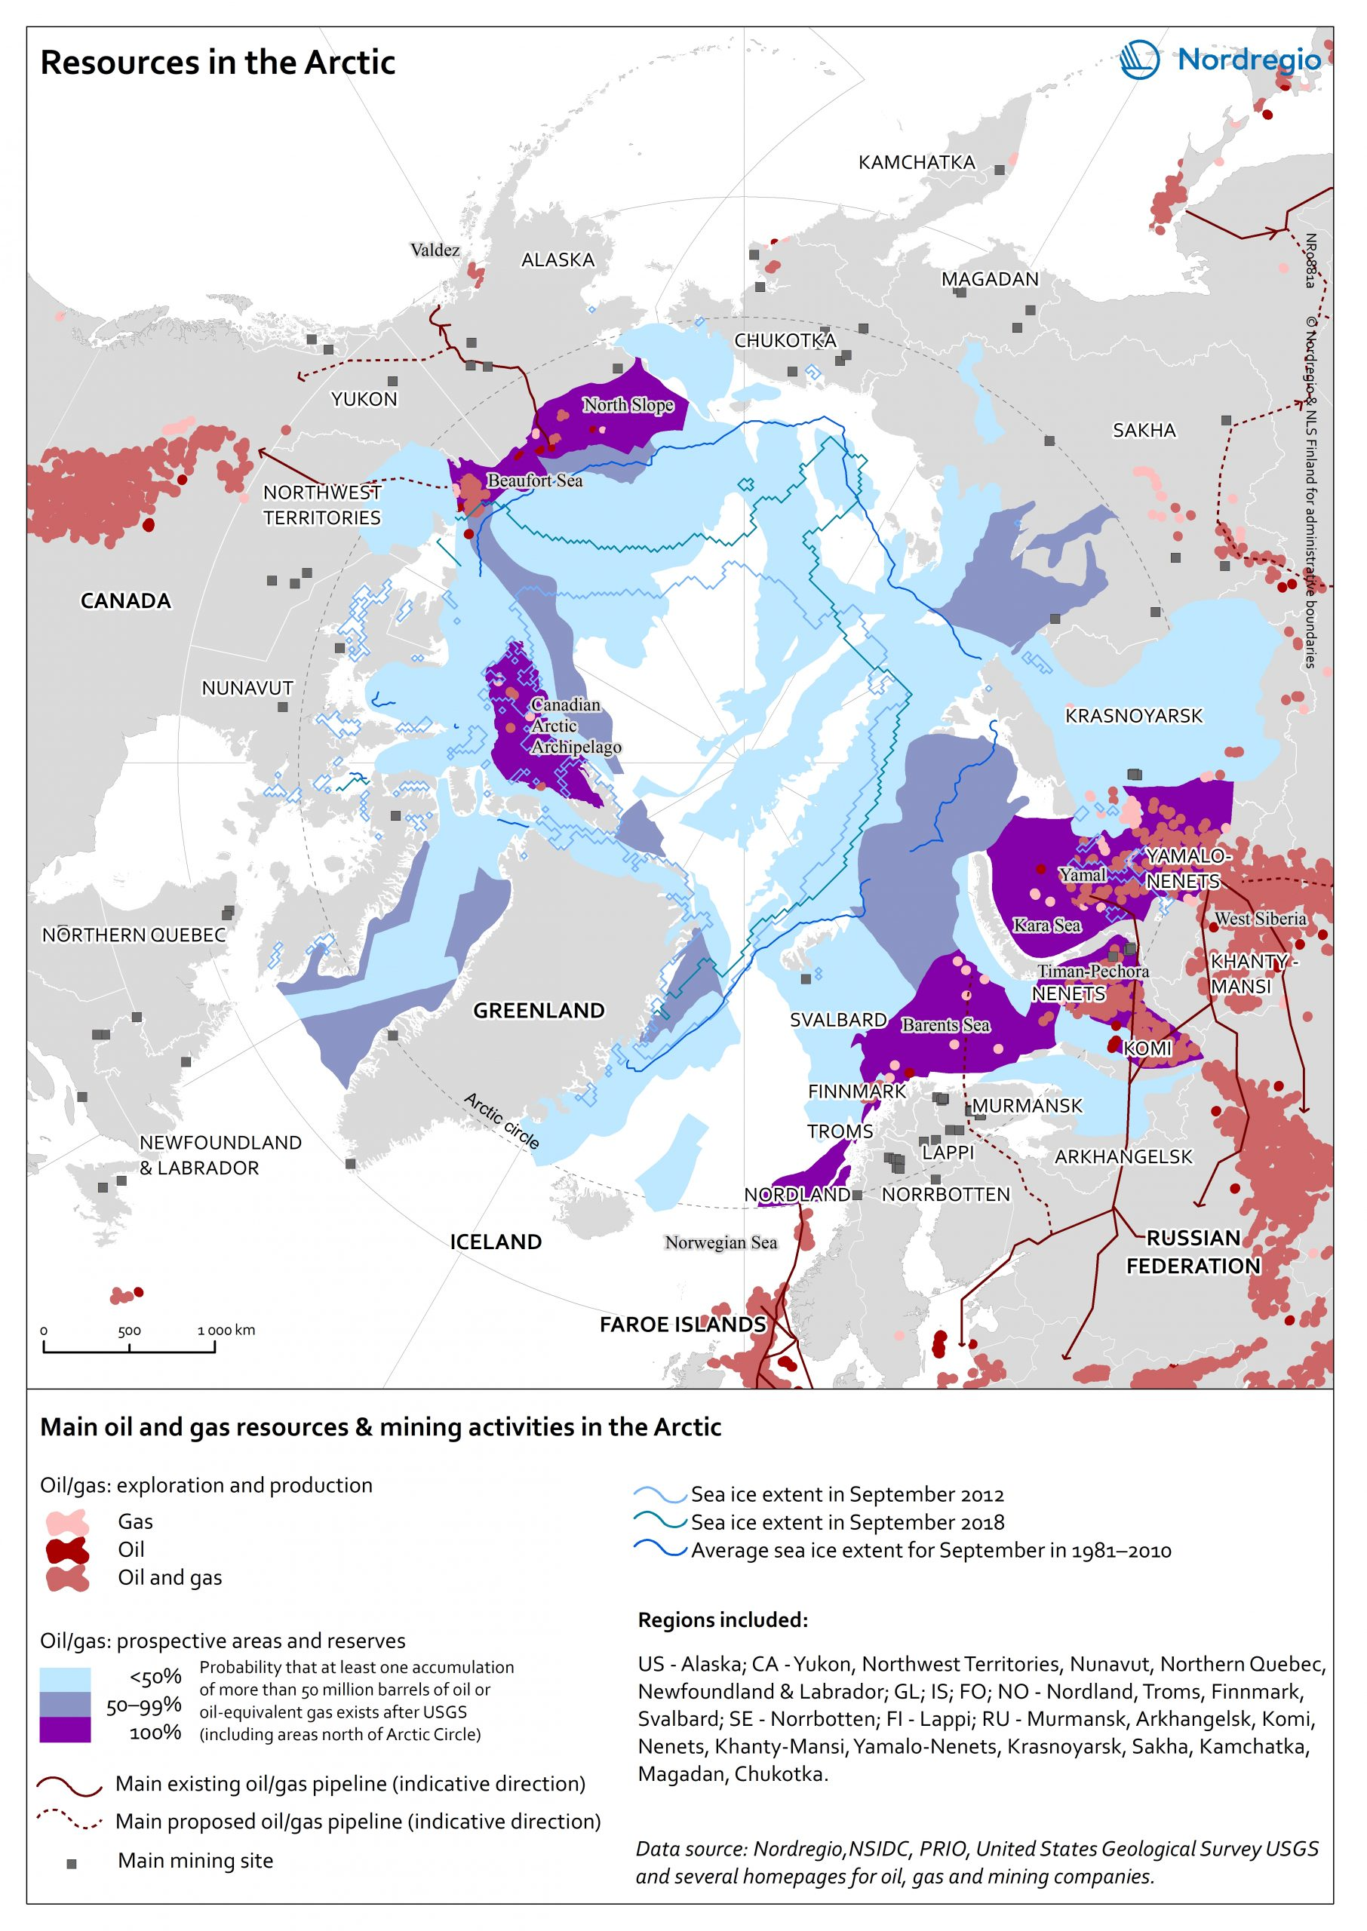

Related Researchers

Eeva Turunen
Junior Research Fellow/ Cartographer

- Sea Routes and Ports in the Arctic, map provided by Nordregio, available at: https://nordregio.org/maps/sea-routes-and-ports-in-the-arctic/

Sea Routes and Ports in the Arctic
The main and secondary zones for maritime traffic are based on 2017 vessel traffic data gathered on Automatic Identification System (AIS) by Marine Traffic (blue colours on map). The data shows the locations of vessels during their travels.
The main transport areas are in Northern Europe – from Iceland to the Kara Sea through the Norwegian coast – and along the coast of Alaska (USA).
Cargo ships as well as government vessels, including icebreakers, account for the largest share of the traffic in the Arctic. The number of tourism-related shipping activity and private yachts is increasing.
The main transport corridors in the Arctic, the Northern Sea Route in the Russian Federation, the Northwest Passage in Canada and the Arctic Bridge from Canada to Europe have all experienced significant growth in the maritime traffic in the recent years. The Northern Sea Route is the shortest route between Europe and the Asia-Pacific region is competing with traditional trade lines. Between 2016 and 2017 the cargo volume in Northern Sea Route increased by nearly 40%. In the Canadian Arctic the traffic has almost tripled between 1990-2015.
When it comes to the increasing maritime traffic in the Arctic, the interests of economic potentials and challenging physical conditions are balancing. Even if the sea ice coverage is decreasing, the Arctic region is still a challenging environment. In the wintertime ice floes lack predictability and the conditions vary seasonally. Traveling across multiyear ice – that can be more than three meters thick – is challenging even for icebreakers which progress better across first-year ice – less than one meter thick. Icebreaker escorts in the wintertime are not only costly but are also limiting the maximum width of the vessel escorted. During the open water season the transit is often challenging due to severe storms or heavy fog that is obscuring visibility – thus leading to decreased transit speed. The lack of infrastructure in the region further complicates the transits.
As shown in the map there are some 350 ports on the coasts of the Arctic Ocean that are included to World Port Index’s database published by the US National Geospatial-Intelligence Agency. The World Port Index provides the location and physical characteristics, as well as the facilities and services offered by major ports and terminals worldwide. In this map we have chosen to categorise the ports by size and ice conditions. The classification uses several factors, including area, facilities, and wharf space. Based on this classification the port of Murmansk is the only large port in the Arctic. In addition, ten medium sized ports exist in the Arctic. Almost 200 in the Arctic ports are ice free year around.
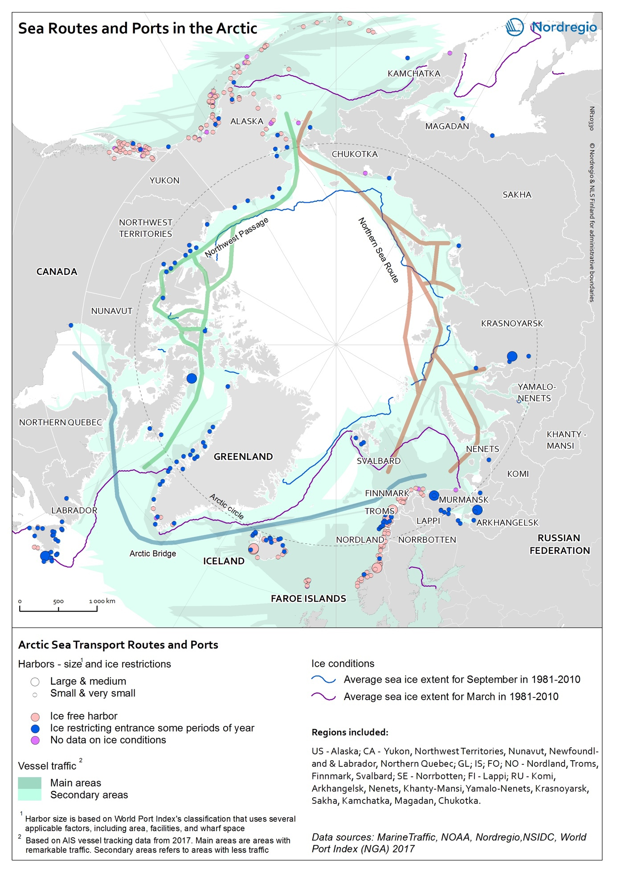

https://www.cnbc.com/2020/11/21/oil-versus-climate-change-the-economics-of-drilling-in-the-arctic.html
Oil versus climate change: The economics of drilling in the Arctic
PUBLISHED SAT, NOV 21 20209:00 AM EST
Andrea Miller@ANDREACNBC
The Arctic is not a barren, frozen wasteland. It’s home to some of the most unique ecosystems in the world. More than this: it’s home to people.
Those people are at the center of the controversy over drilling for oil in the Arctic.
The Trump administration is now starting the formal process of selling leases in the Arctic National Wildlife Refuge to oil companies, according to the New York Times. The move comes after the Trump administration opened the refuge for oil drilling in August 2020.
There are potentially billions of dollars in untapped oil and gas reserves in the Arctic. But, there is value in keeping the region untouched, too. The Arctic provides more than $281 billion per year in fishing, oil, mineral extraction, tourism and climate stabilization services, according to a preliminary assessment done in 2016 by environmental economist Tanya O’Garra, who worked at the Center for Research on Environmental Decisions at Columbia University at the time the research was conducted.
“The Arctic provides the entire world with climate stabilization, and in the absence of that, we may well see changing growing seasons, more hurricanes, more droughts and more unstable climate,” O’Garra told CNBC.

https://apnews.com/article/alaska-arctic-wildlife-refuge-oil-gas-drilling-biden-b9f20088957d42e99b791ff94169198f

Biden suspends oil leases in Alaska’s Arctic refuge
By MATTHEW DALY June 2, 2021
WASHINGTON (AP) — The Biden administration on Tuesday suspended oil and gas leases in Alaska’s Arctic National Wildlife Refuge, reversing a drilling program approved by the Trump administration and reviving a political fight over a remote region that is home to polar bears and other wildlife — and a rich reserve of oil.
The order by Interior Secretary Deb Haaland follows a temporary moratorium on oil and gas lease activities imposed by President Joe Biden on his first day in office. Biden’s Jan. 20 executive order suggested a new environmental review was needed to address possible legal flaws in a drilling program approved by the Trump administration under a 2017 law enacted by Congress.
After conducting a required review, Interior said it “identified defects in the underlying record of decision supporting the leases, including the lack of analysis of a reasonable range of alternatives″ required under the National Environmental Policy Act, a bedrock environmental law.
The remote, 19.6 million-acre refuge is home to polar bears, caribou, snowy owls and other wildlife, including migrating birds from six continents. Republicans and the oil industry have long been trying to open up the oil-rich refuge, which is considered sacred by the Indigenous Gwich’in, for drilling. Democrats, environmental groups and some Alaska Native tribes have been trying to block it.
Environmental groups and Democrats cheered the Interior Department order, while Alaska’s all-Republican congressional delegation slammed it as misguided and illegal.
The U.S. Bureau of Land Management, an Interior agency, held a lease sale for the refuge’s coastal plain on Jan. 6, two weeks before Biden took office. Eight days later the agency signed leases for nine tracts totaling nearly 685 square miles (1,770 square kilometers). However, the issuance of the leases was not announced publicly until Jan. 19, former President Donald Trump’s last full day in office.
Biden has opposed drilling in the region, and environmental groups have been pushing for permanent protections, which Biden called for during the presidential campaign.
The administration’s action to suspend the leases comes after officials disappointed environmental groups last week by defending a Trump administration decision to approve a major oil project on Alaska’s North Slope. Critics say the action flies in the face of Biden’s pledges to address climate change.
The Justice Department said in a court filing that opponents of the Willow project in the National Petroleum Reserve-Alaska were seeking to stop development by “cherry-picking” the records of federal agencies to claim environmental review law violations. The filing defends the reviews underpinning last fall’s decision approving project plans.
Kristen Miller, acting executive director of the Alaska Wilderness League, hailed suspension of the Arctic leasing program, which she said was the result of a flawed legal process under Trump.
“Suspending these leases is a step in the right direction, and we commend the Biden administration for committing to a new program analysis that prioritizes sound science and adequate tribal consultation,″ she said.
More action is needed, Miller said, calling for a permanent cancellation of the leases and repeal of the 2017 law mandating drilling in the refuge’s coastal plain.
The drilling mandate was included in a massive tax cut approved by congressional Republicans during Trump’s first year in office. Republicans said it could generate an estimated $1 billion over 10 years, a figure Democrats call preposterously overstated.
Sen. Maria Cantwell, D-Wash., a longtime opponent of drilling in the refuge, accused the Trump administration of trying to “shortcut environmental laws.″ The effort “fell apart when exposed to the facts that federal scientists say Arctic Refuge drilling cannot be done safely and oil companies don’t want to drill there,” Cantwell said.
“Now it is up to Congress to permanently protect this irreplaceable, million-year-old ecosystem and facilitate new economic opportunities based on preserving America’s pristine public lands for outdoor recreation,” she said.
Bernadette Demientieff, executive director of the Gwich’in Nation Steering Committee, said in a statement that tribal leaders are heartened by the Biden administration’s “commitment to protecting sacred lands and the Gwich’in way of life.”
She thanked Biden and Haaland “for hearing our voices and standing up for our human rights and identity.″
In a joint statement, Alaska Sens. Dan Sullivan and Lisa Murkowski, along with Rep. Don Young and Gov. Mike Dunleavy, criticized the Interior Department action. All four are Republicans.
Dunleavy said the leases sold in January “are valid and cannot be taken away by the federal government.″
Sullivan, who praised Biden last week for backing the Willow oil project, said suspending the Arctic leases “goes against the law, facts, the science and the will of the Native communities on the North Slope. It is nothing more than a naked political move by the Biden administration to pay off its extreme environmental allies.″
Murkowski called the order expected “but outrageous nonetheless.”
Murkowski, who provided a key vote for Haaland’s confirmation in March, said the secretarial order “is in direct conflict with the 2017 Tax Cuts and Jobs Act,″ which “specifically states that the purpose of the (designated) area of ANWR is oil and gas development.″
“This action serves no purpose other than to obstruct Alaska’s economy and put our energy security at great risk,″ Murkowski said.

REUTERS : https://www.reuters.com/article/us-norway-oil-environment-idUSKBN28W104

COMMODITIES NEWS
DECEMBER 22, 202010:57 AMUPDATED 10 MONTHS AGO

Norway supreme court verdict opens Arctic to more oil drilling
By Nerijus Adomaitis
3 MIN READ
OSLO (Reuters) - Norway’s supreme court upheld government plans for Arctic oil exploration on Tuesday, dismissing a lawsuit by campaigners who said they violated people’s right to a healthy environment.
Slideshow ( 3 images )
While most of Norway’s oil output flows from south of the Arctic, the government believes the greatest untapped potential lies in the Barents Sea off Europe’s northernmost coast.
Tuesday’s verdict upheld rulings by two lower courts, rejecting arguments by Greenpeace and the Nature and Youth group that a 2015-2016 oil licensing round giving awards to Equinor and others had breached Norway’s constitution.
While the case was specifically about ten exploration licenses awarded four years ago, the campaigners had hoped that their appeal would set a precedent limiting the oil industry’s Arctic expansion.
Norway is western Europe’s largest oil and gas producer, with a daily output of around 4 million barrels of oil equivalent.
“The supreme court is rejecting the appeal,” Chief Justice Toril Marie Oeie said as she announced the verdict, which saw 11 of the 15 judge panel rule in favour of the government, while 4 said the environmental groups should have won.
“This means today’s youth lacks fundamental legal protection from environmental damage jeopardising our future... This is shocking and we are furious,” the Nature and Youth group said on Twitter in response to the ruling.
The plaintiffs said pumping more oil would lead to increased climate-warming carbon dioxide emissions and ultimately violate Norway’s constitution as well as its commitments under the Paris climate agreement and the European Convention on Human Rights.
The majority concluded, however, that parliament and the government had broad authority to award new oil acreage.
“A broad majority in parliament has repeatedly rejected proposals to end Norwegian oil extraction,” the judges said.
The Ministry of Energy and Petroleum has announced plans for another round of Arctic licensing awards, setting an application deadline for early next year.
Editing by Terje Solsvik and Alexander Smith
Our Standards: The Thomson Reuters Trust Principles.
MORE FROM REUTERS

https://apnews.com/article/europe-business-climate-environment-and-nature-climate-change-6ac3a74848b2cf7c89d18c348b19e3a7

Greenland suspends oil exploration because of climate change
July 16, 2021

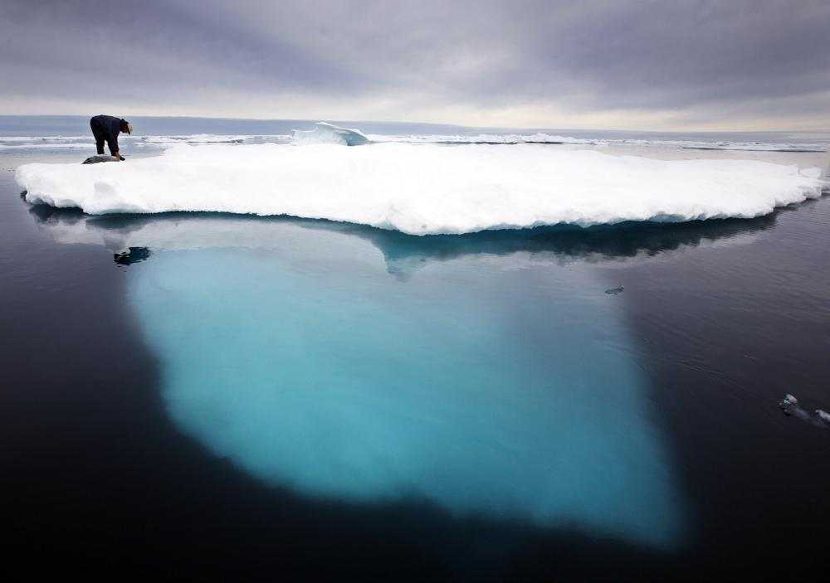
1 of 2
FILE - In this file photo dated July 2007, an Inuit seal hunter touches a dead seal atop a melting iceberg near Ammassalik Island, Greenland. The left-leaning government on Greenland which could be sitting on vast amounts of oil, has decided to suspend all oil exploration, Friday July 16, 2021, calling it “a natural step” because the Arctic government “takes the climate crisis seriously.” (AP Photo/John McConnico, FILE)

COPENHAGEN, Denmark (AP) — The left-leaning government of Greenland has decided to suspend all oil exploration off the world’s largest island, calling it is “a natural step” because the Arctic government “takes the climate crisis seriously.”
No oil has been found yet around Greenland, but officials there had seen potentially vast reserves as a way to help Greenlanders realize their long-held dream of independence from Denmark by cutting the annual subsidy of 3.4 billion kroner ($540 million) the Danish territory receives.
Global warming means that retreating ice could uncover potential oil and mineral resources which, if successfully tapped, could dramatically change the fortunes of the semiautonomous territory of 57,000 people.
“The future does not lie in oil. The future belongs to renewable energy, and in that respect we have much more to gain,” the Greenland government said in a statement. The government said it “wants to take co-responsibility for combating the global climate crisis.”
The decision was made June 24 but made public Thursday.
The U.S. Geological Survey estimates there could be 17.5 billion undiscovered barrels of oil and 148 trillion cubic feet of natural gas off Greenland, although the island’s remote location and harsh weather have limited exploration.
When the current government, led by the Inuit Ataqatigiit party since an April’s parliamentary election, it immediately began to deliver on election promises and stopped plans for uranium mining in southern Greenland.
Greenland still has four active hydrocarbon exploration licenses, which it is obliged to maintain as long as the licensees are actively exploring. They are held by two small companies.
The government’s decision to stop oil exploration was welcomed by environmental group Greenpeace, which called the decision ”fantastic.”
“And my understanding is that the licenses that are left have very limited potential,” Mads Flarup Christensen, Greenpeace Nordic’s general secretary, told weekly Danish tech-magazine Ingenioeren.
Denmark decides foreign, defense and security policy, and supports Greenland with the annual grant that accounts for about two-thirds of the Arctic island’s economy.

https://thebarentsobserver.com/en/arctic/2020/01/avoiding-arctic-sea-routes-might-be-good-intention-isnt-solving-problem

Arctic shipping boycott gains support among big businesses, but not all are happy
By

Thomas Nilsen
35
January 14, 2020
A new group of well-known consumer goods companies have signed up to the pledge not to sail their products through the Northern Sea Route, the Northwest Passage or a future Transpolar Sea Route.
The pledge was launched last autumn by the environmental NGO Ocean Conservancy and Nike.
The promise now signed by companies like Ralph Lauren Corporation, Kuehne + Nagel, PUMA, H&M Columbia and Gap Inc. says «we voluntarily agree not to intentionally allow our product to be trans-shipped on vessels via Arctic Trans-Shipment Routes.»
“Similarly, no ocean carrier or freight forwarder retained by us may have our product on a vessel sailing or intending to sail these Arctic Trans-Shipment Routes.”
Ocean Conservancy points to the accelerating impact of climate change on the Arctic marine environment and decline of sea ice.
The environmental group, based in Washington D. C., United States, argues that increasing vessel traffic is a risky prospect for the Arctic because of polar darkness, far distances to infrastructure and rescue assistance, unpredictable and extreme weather conditions as well as sensitive ecosystems.

Although gaining more and more and more companies to sign up, the pledge to avoid Arctic shipping is also meet by skepticism.
“This is a trend that’s been growing for the past years,” says Heather Exner-Pirot, a research associate at the Observatoire de la politique et la sécurité de l’Arctique (OPSA) and the managing editor of the Arctic Yearbook.
“We saw Barclay’s say they won’t finance Arctic drilling, the Seattle City Council say they would avoid doing business with any company that leases in the Alaskan Arctic, and now a series of the world’s largest shipping companies say they will avoid Arctic routes,” Exner-Pirot says.
She believes it’s a danger if this avoiding Arctic projects becomes seen as trendy or righteous.
“I don’t think there’s a lot there that protects the environment – these shipping companies weren’t using Arctic routes yet - but it casts an entire region as off limits to development,” Heather Exner-Pirot argues.
“That is going to have an effect on real people who need jobs and local governments that need revenues. I think they’re good intentions with terrible, unintended consequences.”
Exner-Pirot’s warning is supported by Sigurd Enge, advisor on Arctic shipping with the Norwegian based environmental group Bellona.
“A campaign aimed at boycotting Arctic shipping in general is a very black and white way of looking at it,” Enge says.
He makes clear that it is, though, very good news that international companies are focusing on Arctic environment.
“There will be shipping in the Arctic in the future and then the focus must be on the needed low- and zero emission solutions,” Sigurd Enge argues.
He calls on the global business- and shipping companies to support a ban on using heavy fuel oil in the Arctic.
environmental groups in the Clean Arctic Alliance are working for a ban on heavy fuel oil in the Arctic. This is the core of the environmental impact caused by Arctic shipping,” Enge states.
The vast majority of Arctic shipping today is domestic Russian vessels traversing parts of the Northern Sea Route, in particular along the route from Murmansk to the waters around the Yamal Peninsula.
However, with sea ice retreating due to the ongoing climate crisis, the Arctic is expected to see a sharp increase in shipping in the years to come.
Heather Exner-Pirot fears the boycott activism will hamper development for people living up north.
“I feel like this ‘boycott Arctic’ thing is a really slippery slope down which northern development may fall, by lack of investors for any activity deemed unsustainable by southern activists,” she says and adds:
“Economic development is a human right.”
The Ocean Conservancy group recognizes that some companies may refuse to sign up for the pledge to avoid Arctic shipping. Therefore, the agreement also expresses support to the development of precautionary Arctic shipping practices to enhance the environment and human safety of current and future Arctic shipping.
“These practices may include a ban on heavy fuel oil use,” the text read and points to the need to adopt strict pollution controls, as well as evaluation of low impact shipping corridors that protect important ecological and indigenous cultural areas.
In total, 20 companies have agreed not to use any of the Arctic shipping lanes.
Among the shippers on the list are Hapag-Lloyd, Mediterranean Shipping Co. (MSC) and the French container transportation group CMA CGM.
For Nike, who initiated the campaign together with Ocean Conservancy, it’s all about protecting the planet.
Hilary Krane, Chief Administrative Officer & General Counsel of Nike, writes in a statement that Nike has made a clear choice on how to deliver its products:
“We’ve made a commitment to not intentionally allow our products to be shipped on vessels via any Arctic sea route.”
Krane points to studies estimating that the Northern Sea Route could be used for approximately 8% of total trade between Asia and Europe by 2030 and even more in the years after.
“Even with regulation, substantial and irreversible risk to the environment exists in the form of oil spills, emissions, vessel strikes and invasive species, which not only impact marine life, but also the human populations that rely on a healthy Arctic ecosystem for their livelihood,” Hilary Krane argues.
“It shouldn’t be an option for anyone,” she says.

Discussion of three articles chosen by the students in advance
e.g.:
- Natural resources: “The battle over Greenland's untapped natural resources” (https://www.dw.com/en/the-battle-over-greenlands-untapped-natural-resources/a-57138809)
A fight over Greenland's rich oil, gas and mineral deposits is raging, as global warming melts ice and exposes rich reserves. Now Greenlanders are struggling to balance economic growth and environmental protection.
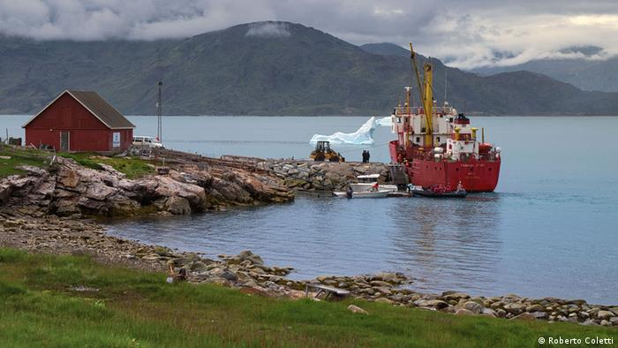
Some in Greenland's fishing communities are relieved a proposed rare-earth mineral mine will likely not go ahead
Third-generation farmer Naasu Lund surveys her land, the silence punctuated only by a fierce wind and the bleating of grazing sheep. Her farm, near the town of Narsaq in southern Greenland, is located just 7 kilometers (4.3 miles) from a proposed uranium and rare earth elements mine.
She had been worried that the surrounding nature and her farm, which also hosts holidaymakers hoping to enjoy Greenland's untouched countryside, would be in jeopardy. She can breathe a sigh of relief. The mine has been halted for now.
"We are guardians of this land … and consider ourselves to be a part of nature," said Lund. "We have now the opportunity to develop it in the way we feel it is fair to do."
The proposed Kvanefjeld mine became a flash point for elections in Greenland this month, toppling the pro-mine Siumut party, which has had an almost uninterrupted hold on power since 1979, when the country gained home rule from Denmark.
Now, the pro-independence Inuit Ataqatigiit (IA) is Greenland's largest party after it ran a green and anti-mine platform. It's promised the Kvanefjeld project will not go ahead, although it must first enter coalition negations with other parties, including Siumut.
Inuit Ataqatigiit members celebrate after winning snap elections on an environmental and anti-mine platform
The controversy over the mine reveals a split on the island over balancing future economic development with protecting the pristine Arctic environment. And the debate has heated up in recent years as global warming melts Greenland's ice cover to reveal rich mineral, oil and gas resources that are attracting international interest from countries like the China and the United States.
"Rare earths can attract many countries, but China has a monopoly on the technology and the necessary skilled labor for the extraction processes," said Jesper Willaing Zeuthen, an associate professor at the University of Aalborg in Denmark and an expert on Arctic-China relations.
Environment vs. development
Kvanefjeld is home to one of the world's largest undeveloped deposits of rare-earth elementsoutside of China. Seventeen elements, including scandium and yttrium, are buried deep underground there. They are used in everything from cell phones and wind turbines to electric cars. Mining advocates say tapping into them would be a major financial boon for Greenland.
Greenland Minerals Limited (GML), the Australian company developing the mine, said that the country would receive $240 million (€201 million) in taxes and royalties annually over the mine's planned 37-year lifespan. GML's biggest stakeholder is Shenghe Resources Holding, a Chinese rare-earths processing company.
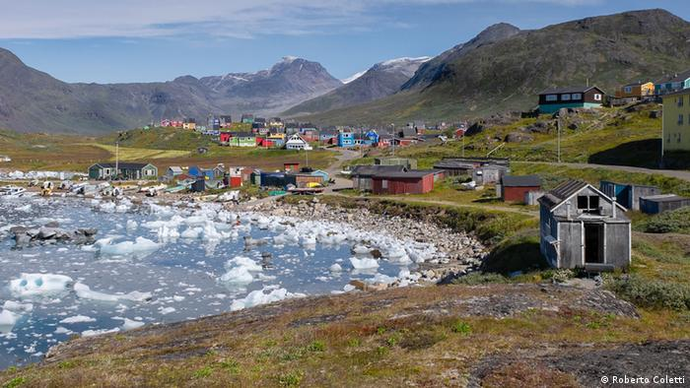
Residents of the picturesque village of Narsaq were concerned about water, air and soil pollution from the proposed mine
For an economy largely dependent on fishing, tourism and a $600 million annual subsidy from Denmark, resource exploitation is seen as a way to boost government coffers and provide a path to independence. Polls indicate support for secession from Denmark. One carried out in 2018 by researchers from the University of Copenhagen found around 67% of respondents supported an independent Greenland at some point in the future.
"It is not certain that the Kvanefjeld mine project will never be realized," said Mikaa Mered, a lecturer on Arctic affairs at HEC business school in Paris. "If the Siumut party returns to power in the future, the struggle for independence could still be played through the uranium mines."
But Kvanefjeld's opponents argue that economic arguments are overplayed, saying it won't bring jobs, because the expertise to develop, extract and process rare-earth minerals doesn't exist on the 56,000-strong island. Furthermore, they argue, the potential threat to the island's pristine ecosystem is underestimated.
"Normally, local people don't earn money from mines as promised in the beginning, but after mining they are left with polluted land," said Mariane Paviasen, an IA member of parliament from Narsaq who has been campaigning against the mine since 2013, speaking of similar projects around the world.
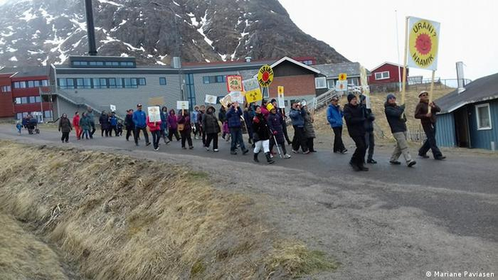
One of the biggest concerns for Narsaq residents was the mining of the radioactive substance uranium
Narsaq's largely Inuit population were concerned that dust from uranium and other radioactive byproducts would be blown across the landscape. Locals and environmentalists, including Friends of the Earth Denmark, worried about contamination of soil, water and marine life from mining waste. Fishing is one of the town's main industries.
"Our life depends on the sea," said Ole Jorgen Davidsen, a fisherman and member the country's fishers' association KNAPK. "Our cultural heritage, our economy and even our free time are linked to where we live. Fishing is the livelihood method for the majority of families here."
GML refused to comment on the electoral outcome and what it would mean for the project but told DW before the election that it had done robust safety and environmental assessments.
"GML has used world experts in all possible environmental risk areas of the project to determine the impacts," said Jorn Skov Nielsen, the company's Executive General Manager.
A green path to independence?
For Lill Rastad Bjorst, associate professor of social science at Aalborg University, Inuit Ataqatigiit's electoral success is indicative of the importance of the environment to Greenlanders' identity and the mark left on Inuit communities by Denmark's colonization of the country. Some 88% of the island's population is Inuit or Danish-Inuit.
Bjorst has been working with the Narsaq community since 2013 and said locals felt like "bystanders to the development project" as Inuit communities have been to the 300 years of development in the country under direct Danish rule, which stretched from the early 18th century to 1979.
The IA party, she says, wants to achieve independence over time by allowing Greenland to grow economically and by improving livelihoods with a "respect for the environment." That could include improving agricultural production at home "to reduce our ecological footprint linked to transport and look for alternative ways to independence," according to IA's Mariane Paviansen. The country now largely relies on food imports.
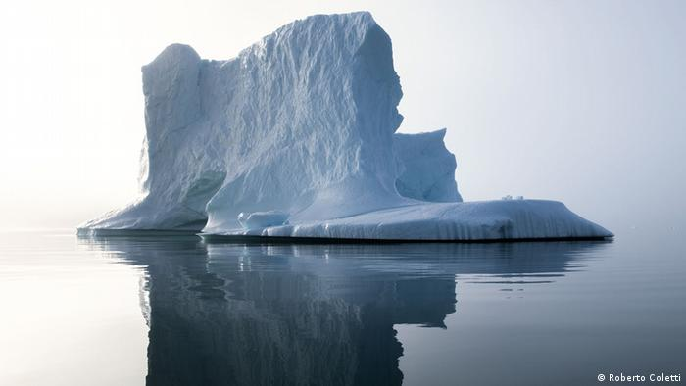
An iceberg floating off Narsaq town. As Greenland warms, its rich mineral deposits are opening up to speculation
With the Arctic warming twice as fast as the rest of the world, the party has also promised to sign up to the Paris Agreement.
Still, a poll in local newspaper "Sermitsiaq" ahead of the election showed that while 63% of respondents were against the Kvanefjeld mining project, just 29% were against mining in general. And as climate change continues to make Greenland's natural resources more accessible and attract more international interest, Greenlanders will have to continue to find the balance between economic development and environmental protection.
"The Inuit Ataqatigiit party doesn't want uranium mining, but it has not ruled out mining activities involving zinc and gold," said lecturer Mikaa Mered. "This may be part of the Greenlandic development plan which has not yet be presented by the party."

- Shipping: “Arctic Cargo Ship Violates Safety Rules Prompting Month-Long Rescue Operation“ (https://www.highnorthnews.com/en/arctic-cargo-ship-violates-safety-rules-prompting-month-long-rescue-operation)
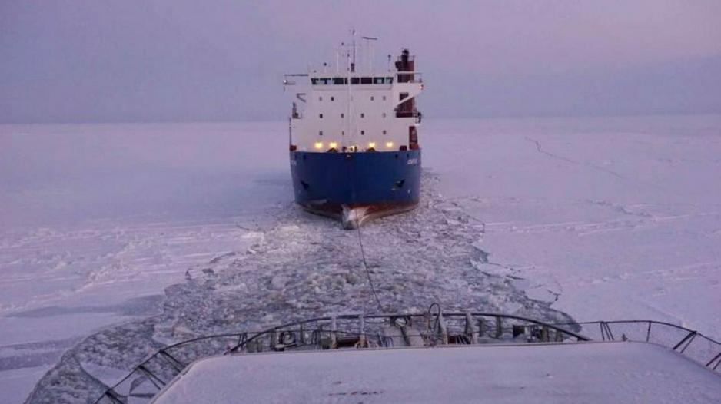
Cargo ship Sparta III traveling under tow after sustaining damage. (Source: Ministry of Transport of the Russian Federation)
Published at: Jan 14 2021 - 08:27 / Updated at: Jan 14 2021 - 08:27

An Arctic cargo ship, Sparta III, violated safety rules and sailed into unsafe ice conditions. It took nearly four weeks, several icebreakers and rescue ships to escort it to safety.

FROMMALTE HUMPERT
Safety violations continue unabated along Russia’s Northern Sea Route (NSR). The four-week saga surrounding the rescue of Sparta III, a general cargo vessel with a light-to-medium ice classification, is just the latest example of how shipping operators ignore established navigational rules in the Arctic and face little if any repercussions from government regulators. High North News previously reported that dozens of vessels have traveled into sections of the NSR for which they have not received a permit.
The latest incident occurs against the backdrop of ambitious targets for growing cargo volume on the route. According to shipping experts there likely exists ongoing pressure from the Kremlin to reach President Putin’s goal of expanding traffic to reach 80m tons in 2024 and safety concerns may take a back seat to economic considerations. In 2020 the route saw around 33m tons.

Deviating from approved route
The Sparta III, a 13,000 ton and 142 meter general cargo vessel, deviated from its approved route at the end of November. The vessel, operated by Oboronlogistics, a transport service provider of the Russian Ministry of Defense, had received a permit from the Northern Sea Route Administration to sail without icebreaker escort from the western entrance of the route to the Port of Sabetta on the Yamal Peninsula and back.
For unknown reasons Oboronlogistics decided to violate Sparta III’s permit and travel into the Gulf of Yenisei all the way to Dudinka where the vessel encountered substantial early season ice buildup. Similar violations have been recorded by the NSR Administration between 2015 and 2018 at which public record-keeping ceased
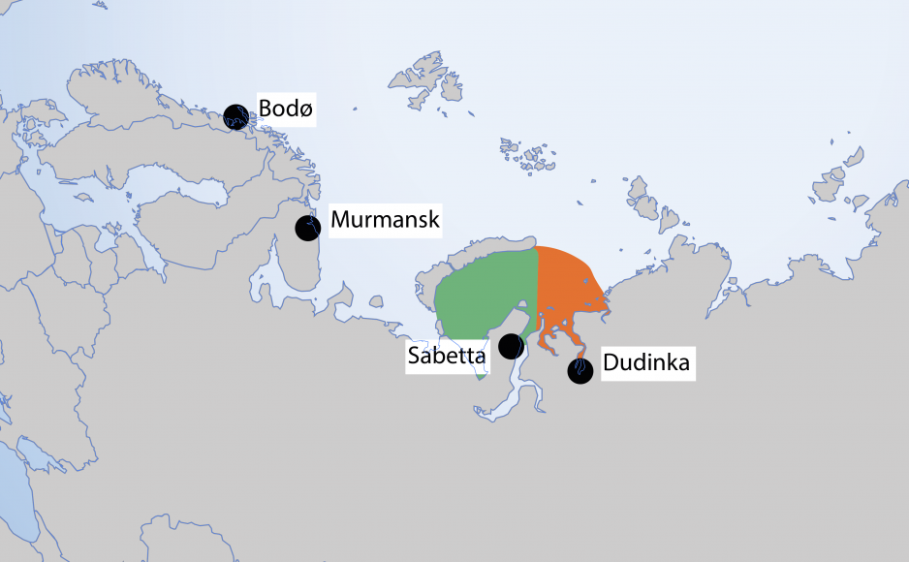
Sparta III’s NSR permit allowed for navigation up to Sabetta (green zone) but not for travel to Dudinka (orange zone). (Source: Author’s own work)

Lack of regulatory oversight and enforcement
Safety violations and a lack of enforcement point to the larger issue of who holds regulatory control over the NSR. In 2019, some elements, including the NSR Administration, who issues permits, were consolidated under the roof of Atomflot – the operator of Russia’s nuclear icebreakers. But the Ministry of Transportation continues to play a role, especially with respect to transport policy along the route.
Furthermore, in an effort to drive shipping and allow more vessels to travel on the route, ice-class requirements were substantially reduced in 2019 as well.
Frédéric Lasserre.
“The accident in itself may buttress the idea Russian authorities are much more tolerant, if not overtly lenient, especially since Rosatom took control of movements control and management. The fact accidents are no longer recorded gives credit to that theory,” explains Arctic shipping expert and Professor at the Université Laval Québec, Frédéric Lasserre.
In a statement Atomflot condemned Oboronlogistics’ actions, but it remains to be seen if the operator will face sanctions.
“The cargo ship Sparta III headed towards the port of Dudinka without permission, and put the fulfillment of its voyage assignment above the safety of navigation and the interests of other companies operating in the water area of ​​the Northern Sea Route,” stated Atomflot’s general director Mustafa Kashka.

Odyssey begins after deviating from route
After Sparta III deviated from its approved routing, Oboronlogistics hired local icebreaking tug Kigoriak to escort the vessel down the Yenisei. The tug, only suitable for near-coast operations was only allowed to operate independently – without real icebreaker support – until December 1.
In previous years Sparta III concluded its work on the NSR at the end of September further highlighting how out of place its presence on the route was during the months of November and December.
Following the ship’s deviation, inquiries by Russian officials to the ship’s captain on November 23 and November 27 remained unanswered and the vessel continued to travel all the way to Dudinka along the Yenisei estuary and river.
Following worsening weather and ice conditions the two-ship convoy found itself in difficult ice conditions in the southern part of the Yenisei Gulf by December 17 halting all forward progress. The navigation channel had closed up and the two ships encountered hummocks and ice ridges up to 70 centimeters thick.
Atomflot, which routinely operates icebreakers along the NSR during winter, received a request for assistance on December 15. After more than a week of negotiations Atomflot decided to divert one of its nuclear icebreakers, Vaigach, from regular icebreaking services along the NSR on December 24.
After 19 hours the icebreaker had freed Sparta III and Kigoriak from the hummock field and Vaigach returned to regular contracted duties along the NSR.

Requiring assistance a second time
Sparta III made way and navigated together with Kigoriak but less than 24 hours later developed steering control issues due to a damaged rudder, likely from having been stuck in ice for a week, upon exiting the Gulf of Yenisei in difficult ice conditions. Kigoriak was able to break free, leaving Sparta III bound in the ice for more than a week.
On January 1 Vaigach again returned to assist once again and was joined by the diesel-powered icebreaker Admiral Makarov.
The convoy set off on January 2 with Vaigach breaking a channel through the ice and Admiral Makarov towing the damaged cargo ship. As Vaigach had to return to contracted icebreaking duties, Marine Rescue Service ship Rescuer Karev took over towing duties with Admiral Makarov breaking the ice.
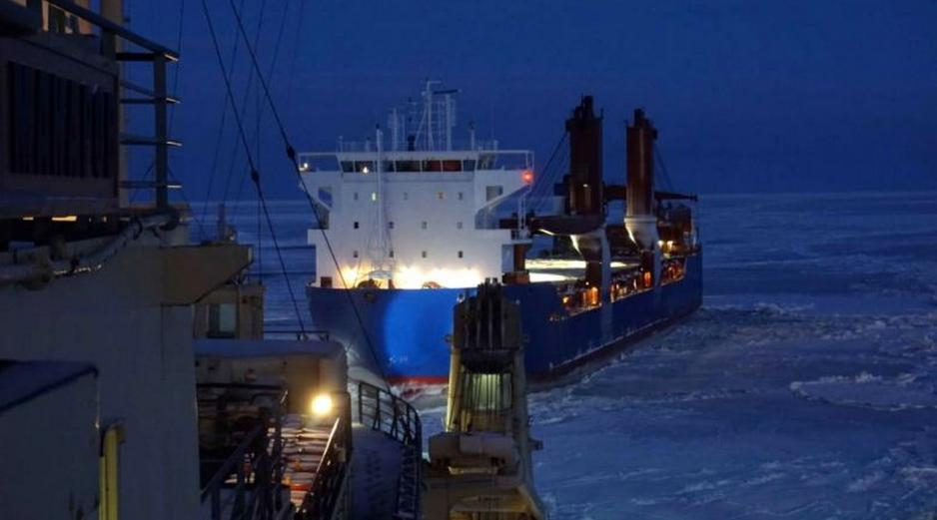
Sparta III being towed through the ice by an icebreaker. (Source: Ministry of Transport of the Russian Federation)
The rescue operation involved a complex tow setup using a 100 meter towing cable. As Atomflot experts explain, traditionally the towing distance should be much shorter as ice buildup in the channel between the two ships puts increasing load on the tow cable. But due Sparta III’s large bulbous bow, which could have damaged the icebreaker’s propeller and steering, this unusual towing arrangement became necessary.
The Icebreaker escort was concluded on January 8 after traveling 410 nautical miles over the course of 6 days and Sparta III continues to be towed by a rescue ship towards the port of Murmansk.

Lack of transparency reduces safety
Over the past decade national regulators and international organizations, especially the International Maritime Organization (IMO), have debated and approved a number of safety measures to enhance safety for shipping in the Arctic. The IMO’s Polar Code went into effect in 2017 setting standards for equipment and crew training when traveling in the region’s icy waters. However, in the light of the rapid growth of shipping traffic along the NSR, from less than 3m tons 10 years ago to more than 30m tons last year, a more transparent and enforceable safety regime for Russian waters has yet to be implemented.
“Rosatom says it is not happy with the Sparta III incident and that the vessel clearly was in violation of the regulations. The shipping company, in my understanding working closely with the military, reportedly did not have formal permission, which the shipping companies denies. Now who says the truth? Hard to say given the fact these players are unlikely to be very transparent,” concludes Lasserre.

Tourism:
Arctic tourism is potential threat to environment as ice melts (https://www.nbcnews.com/news/world/arctic-tourism-potential-threat-environment-ice-melts-n833956)
Jan. 11, 2018, 9:47 AM CET / Updated Jan. 11, 2018, 9:55 AM CET
By Hanna Krueger
For centuries, ambitious mariners pining to traverse the Arctic Circle experienced little more than disappointment — and often death.
But diminishing sea ice and more temperate weather have made traveling through polar waters a vacation rather than an exploration.
The area covered by Arctic sea ice in December was 420,900 square miles smaller than the 1981-2010 average, according to the National Snow and Ice Data Center. That represents an area more than one and a half times the size of Texas — and was the second-lowest level recorded by satellite since 1979.
Nordic countries and Greenland have led the Arctic tourism charge.
In 1990, only 7,952 cruise passengers passed through Iceland. By 2016, a quarter of a million were visiting the country yearly. The Russian Arctic also saw a 20 percent rise in visitors last year, with Chinese tourists accounting for the largest group.
But experts warn that the increasing traffic raises the chance of a catastrophe such as an oil spill or a sewage leak that would damage the pristine polar environment.
“It is a matter of time, not a matter of if,” said Jackie Dawson, an associate professor of geography, environment and geomatics at the University of Ottawa. "We will see some sort of disaster related to climate change and increased human activity in the Arctic."
The Arctic is prone to severe and changing weather conditions that complicate travel and endanger seafarers. The high latitude also disrupts maritime navigational and communication systems. Should an oil spill, a crash or a machinery malfunction occur, the region's remoteness makes an efficient emergency response nearly impossible.
The Northwest Passage — a route through Canada's Arctic Archipelago that is 500 miles north of the Arctic Circle and connects the Atlantic Ocean with the Pacific — was first crossed by sea in 1906.
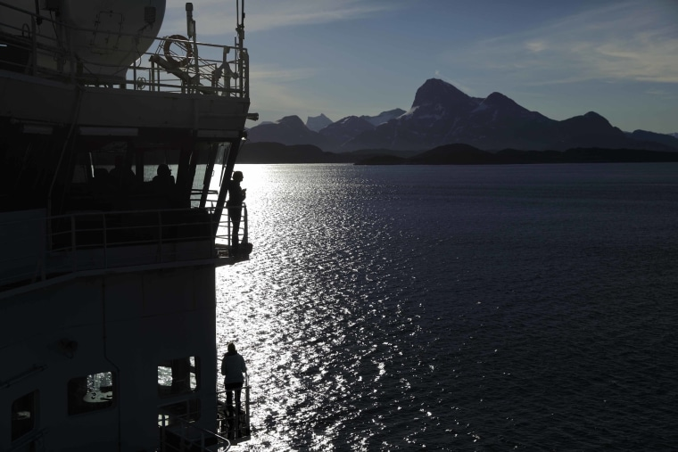
Personnel stand aboard the Finnish icebreaker MSV Nordica as it arrives in Nuuk, Greenland, last summer. Its 6,214-mile journey marked the earliest transit of the Northwest Passage in history. It left Vancouver on July 5 and reached Nuuk on July 29.David Goldman / AP file
The vast majority of Arctic voyages since then have involved minimalist research vessels, according to Marta Bystrowska, a climate scientist completing her Ph.D. thesis in Arctic tourism at the Centre for Polar Studies at the University of Silesia in Poland.
But guests are increasingly hopping aboard Arctic Circle-bound ships expecting a first-class experience along with "elegant menus, comfortable rooms and additional activities such as diving or kayaking during a cruise,” Bystrowska said. “The cruising industry may shift toward bigger and bigger ships to accommodate rising demand and making cruises more profitable.”
In 2016, Crystal Cruises' hulking 13-story cruise liner Serenity traversed the Northwest Passage. In addition to 600 crew members, the ship carried 900 guests who dined in its luxurious restaurant and observed glaciers from private verandas.
Since Serenity’s maiden voyage, other boutique firms have followed suit. Abercrombie and Kent, a British luxury travel company, offers a 24-day, all-inclusive trip through the Northwest Passage for $30,995. Personalized butler service costs another $10,000.
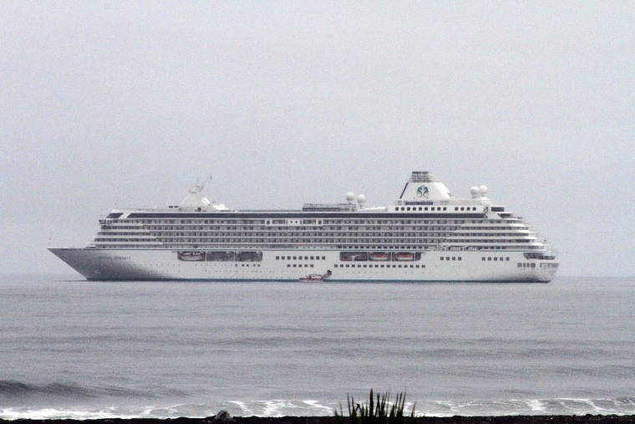
The Crystal Serenity anchored just outside Nome, Alaska, in 2016. The New York-bound ship made the port call as it became the largest cruise ship to ever go through the Northwest Passage.Mark Thiessen / AP file
Quark Expeditions pushes deeper into the heart of the Arctic with an excursion with prices beginning at $28,695. Passengers can shell out another $500 to view the North Pole from a hot-air balloon.

These ships must withstand the grueling conditions that once made the Arctic the planet's most daunting maritime challenge. The International Maritime Organization introduced a Polar Code in 2016 aimed at ensuring that tour operators were prepared for the remoteness and extreme weather of the Arctic. It also prohibits vessels from discarding food waste and sewage.
While the code is mandatory under two international conventions, its enforcement is up to the IMO's 172 member states. It also does not specify what penalties should be imposed for noncompliance.
Crystal Cruises plans next year to start using the Endeavor, a Polar Code-compliant 600-foot megayacht with two helicopters and two seven-person submarines, in the region.
"The Arctic is full of magic. It is one of the most beautiful places on earth"
Its lifeboats are fully enclosed, resembling submarines rather than the typical emergency raft. Head-to-toe thermal suits accompany life jackets. Steaming water cascades down its front instead of a traditional defroster. Axes and shovels are on reserve to combat inevitable ice buildups.
And while thinning sea ice has opened up Arctic waters to tourists, it also hints that there is a time limit on such travel.
The National Oceanic and Atmospheric Administration has already warned the region is heating at twice the rate as the rest of globe. As a result, Arctic tourism has taken on a morbid moniker of “last-chance tourism,” which describes the desire for tourists to witness the landscapes and species before they are gone for good.
“Last-chance tourism plays an important psychological role in influencing people’s decision to take cruises sooner rather than later,” said Dawson, of the University of Ottawa. “I often hear people saying that they had been thinking about taking a cruise in the Arctic but the fact that the climate is changing influenced them to do it now.”
To Dawson, this exposes a dark irony. Tourists may further endanger the Arctic's environment, but their experience may also result in them taking action to protect it after returning home.
“These trips really do change people," she said. "The Arctic is full of magic. It is one of the most beautiful places on earth."
Lesson 4

Gricius, G. (2021) ‘Geopolitical Implications of New Arctic Shipping Lanes’, The Arctic Institute, https://www.thearcticinstitute.org/geopolitical-implications-arctic-shipping-lanes/?cn-reloaded=1

Geopolitical Implications of New Arctic Shipping Lanes
March 18, 2021 By Gabriella Gricius

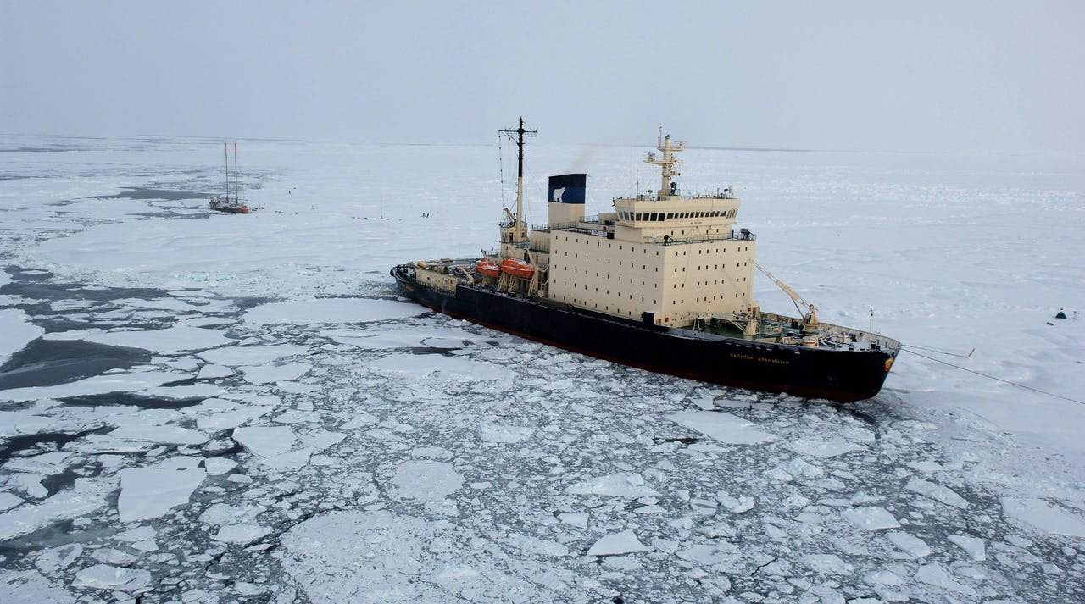
The increasing accessibility of newly open Arctic shipping lanes and ports bring with them troubling geopolitical implications. Photo: NOAA
The advent of climate change has brought about a number of different changes in the Arctic, including increased accessibility to Arctic ports as well as the opening of new Arctic shipping lanes. With new trans-Arctic routes, including the Northern Sea Route (NSR) and the Northwest Passage (NWP), as well as newly built and refurbished ports from Russia, political and military interests are reevaluating the region as one of geopolitical competition. While the Arctic traditionally was characterized by cooperation and low tensions, that is changing. A report from the US Congressional Research Service (CRS) on the Arctic notes that although there is still important cooperation in the region, the Arctic is increasingly seen as an area for geopolitical competition amongst the US, China, and Russia.¹⁾ The article will discuss the geopolitical ramifications of the NSR and NWP as well as the building and refurbishing of ports in the Arctic.
With the emergence of new possible shipping lanes such as the NSR and the NWP, states are changing their behavior in the Arctic. As the ice diminishes, these shorter maritime routes, their respective ports and natural resources are causing a renewal of interest in what was once considered an impassable region. States have expressed interest in using new shipping lanes for shorter transit times, strategic resource extraction, military activity as well as regional shipping, fishing and tourism.²⁾ However, with its unpredictable seas, severe climate conditions, high costs, and lack of developed infrastructure in the northern territories – the Arctic has many obstacles for socio-economic and maritime development.³⁾
Despite these obstacles, this renewed regional interest may lead to increased geopolitical tensions. Increasing traffic brings the possibility of unknown ships close to many of these country’s coasts in a way that they are not familiar with. States then must determine how to control their northern borders in harsh climates and territories that, until recently, were impassable. Without some kind of vigilance over their borders, Arctic states may also run the risk of facilitating or falling victim to increased transnational crime. For example, unknown ships also bring with them unknown purposes, of which many could be illegal fishing or even illicit trafficking. Further, the development of the NSR and NWP also presents possible issues. Unresolved disputes about the sovereignty of these new sea routes may be problematic when shipping does eventually become an option. China and Russia’s cooperation on the development of the NSR also brings with it concerns about Chinese influence in the Arctic as well as American hand-wringing about a closer relationship between Russia and China.

The Northern Sea Route
Although the Northern Sea Route (NSR) was first opened by the Soviet Union in the 1930s, it has not been a reliable transit route for many decades due to ice coverage.⁴⁾ However, with the increasing melting of the polar ice caps, the NSR is looking more and more like a potential transit route. However, there are geopolitical implications concerning the NSR that raise interesting questions. Perhaps the most basic geopolitical consideration is who has power over the NSR. Russia has claimed that the NSR lies within its territorial waters, giving it exclusive rights to develop the area and to patrol ships.⁵⁾ The United States and other powers have disputed this claim, which has led to an interesting paradox where neither side recognizes the veracity of who can control this passageway. Interestingly, Canada does recognize Russia’s claim over the NSR as Russia recognizes Canada’s claim over the NWP (See below).
Another geopolitical concern is the development of the NSR. While the United States has failed for many years to express interest, not all states have taken such an approach. China, for example, is working with Russia to develop the NSR as China sees the route as important for its national economic interests. Although the investment is hugely expensive and time consuming, China clearly sees the development of the NSR as playing the long game.⁶⁾ While the route may not be usable now, in a few decades, that could easily change. Geopolitically, this has huge implications as it brings China and Russia closer together as allies and encourages both states to develop more icebreakers – a necessary tool to navigate the region.

The Northwest Passage
While much of the headlines tend to highlight the importance of the NSR, the Northwest passage (NWP) also raises its own concerns, mirroring those of Russia. Canada claims that the NWP is located in internal Canadian waters and therefore any ship is subject to Canadian law and sovereignty.⁷⁾ With the opening of the NWP, Canadian analysts have also raised concerns about potential environmental disasters, military security, and the security of people. However, the question also comes down to sovereignty as with the NSR.⁸⁾ The United States and the European Union have quibbled with Canada’s claim of sovereignty, claiming that the NWP is an international strait and that there is a non suspendable right of transit. As noted above, Russia and Canada recognize each other’s claim over their respective Arctic passages.
Geopolitically, the opening of the NWP has similar implications as the NSR. While there is less development with other nations, international legal questions still remain unanswered about who has control over the strait. Given the slow rate of change, there is still time to find a compromise to this important geopolitical question before the route is completely free of ice. The second geopolitical concern is of potential disasters and military security in the region. Analysts have pointed to the possibility of terrorists entering Canada from the lightly populated Arctic region – making the opening of this route concerning for Canadian national security. While that seems unlikely due to the high costs of entering Canada in this way, it presents states with new security problems to deal with.

New Ports
One of the more interesting developments in the Arctic has been the development of new ports, both hydrocarbon and military-oriented, throughout the region. Russia is the main mover behind this trend, with Russian militarization of the Arctic a growing concern for many policymakers, particularly in the United States. This buildup can be explained in a few different ways: defense and survivability of second-strike assets, protection of Russia’s commercial interests, and addressing economic challenges in its polar region.⁹⁾ While there may be different reasons for this buildup, there is no question that it is happening. In recent years, Russia has reopened more than 50 Soviet bases in the Arctic, both providing themselves more strategic ports throughout the region as well as sending a message to other countries.¹⁰⁾ No other state has as solid a presence in the Arctic as Russia does. Opening these ports, no matter how practical, send the signal that Russia wants to retain what it sees as a historic domination of the region.
It is tempting to see these new ports as the first step of a geopolitical contest between great powers. The construction of these ports is akin, according to Secretary of State Mike Pompeo, to Chinese actions in the South China Sea, presenting an aggressive pattern of behaviour.¹¹⁾Whether or not that is true, Pompeo’s speech indicates that the US perceives it as such and will react as it sees fit. While it is certainly sending a message, I would argue that it is not done so with the intent to be purely provocative. With the opening of the NSR and increasing hydrocarbon extraction and research, Russia needs more bases to keep track of its growing activity. It is not feasible to expect economic development without subsequent government support in the form of bases. However, this narrative of geopolitical competition is certainly present in both Russia and in Western countries.

Geopolitical Analysis
The opening of new shipping lanes and construction of new ports do not inherently indicate increased geopolitical tensions in the Arctic. However, their consequences do. Increased activity in the NSR and NWP comes with a few geopolitical concerns. As discussed above, the first is that of sovereignty. There is no clarity in either of these shipping lanes as to who actually has power over who can pass and what standards they must adhere to in order to do so. Without this information, there will be increased uncertainty and therefore more possibilities for misunderstandings between states. The second concern is the possibility of transnational crime. With increased traffic in these waterways, Arctic states will have to find some way of monitoring unknown ships and activity. If not, the Arctic may see an increase in illegal fishing and trafficking. This indicates that Arctic states, particularly Canada and Russia, must determine better ways of controlling their northern borders. Imposing more border control measures may imply that there will be increased military and security presence. While an increased security presence might indicate stability, generally it may also lead to rising tensions between powers. A final geopolitical concern is that of the relationship between Russia and China. The development of the NSR has started the beginning of a potential alliance between Russia and China where China provides funding and technology for NSR development and Russia provides both access and future benefits for China who may wish to utilize the NSR. From an American perspective, a Russia-Chinese alliance is concerning as it increases the possibility of Chinese influence in the Arctic as well as brings together two countries who both have poor relationships with the US. Whether or not American stress turns out to be warranted, the US will still act according to this fear and may begin to build up military strength in the Arctic just in case.
While it may seem as though change is happening very quickly in the Arctic, there is still time to prepare for geographic changes up North. States will not have to decide on the fly what new policies will be without coordinating with other Arctic counterparts. In short, geopolitical tensions may be at risk of rising but there is no rush to make decisions without thoroughly considering all of the ways to avoid geopolitical conflict.
Gabriella Gricius is PhD Student at Colorado State University focusing on Arctic politics, Russian studies, and critical security & decolonial theory. She is also a Graduate Fellow with the North American and Arctic Defence and Security Network.

Uryopova, E. (2021), Climate Change and Geopolitics: Monitoring of a Thawing Permafrost, https://www.thearcticinstitute.org/climate-change-geopolitics-monitoring-thawing-permafrost/

Climate Change and Geopolitics: Monitoring of a Thawing Permafrost
March 16, 2021 By Ekaterina Uryupova Article, Climate and Environment, Society and Culture
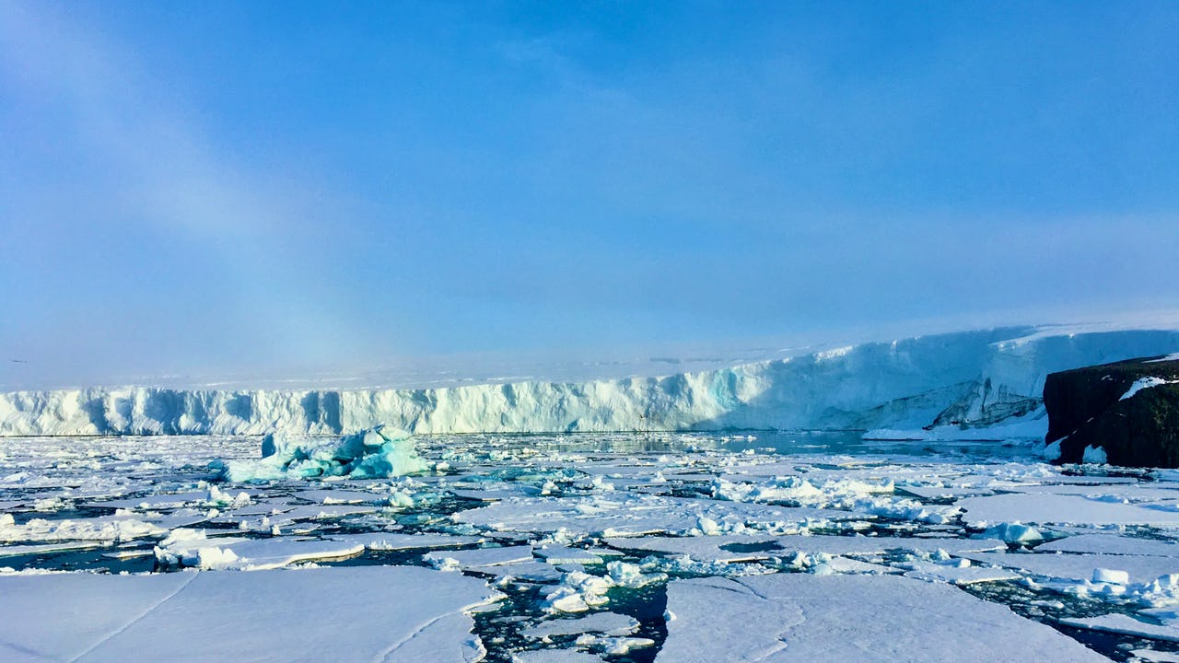
“Frozen Land” – a glimpse of the Franz Josef Land archipelago. Photo: Ekaterina Uryupova
Permafrost thaw is one of the world’s most pressing climate problems, already disrupting lifestyles, livelihoods, economies, and ecosystems in the north, and threatening to spill beyond the boundaries of the Arctic as our planet continues to warm. To examine the effects of permafrost degradation, and increase our understanding of what this phenomenon means for the future of the region (and the world), The Arctic Institute’s new two-part permafrost series aims to analyze the topic from scientific, security, legal, and personal perspectives. The second installment of our series features eight new articles on permafrost degradation and its effects on Arctic life, research, and the world at large. But before, check out the seven articles from our first installment, starting with the Intro.
- Agents and the Arctic: The Case for Increased Use of Agent-Based Modeling to Study Permafrost
- Drunken Forests: Teaching About Permafrost Thaw Through Personal Experience
- The Global Carbon Budget and Permafrost Feedback Loops in the Arctic
- Meltdown – The Permafrost that Holds the Arctic Together is Falling Apart
- Reducing Individual Costs of Permafrost Thaw Damage in Canada’s Arctic
- North but Maybe Not North Enough: Adapting Sub-Arctic Communities and Infrastructure to a Changing Climate
- Infrastructure and Community Resilience in the Changing Arctic: Status, Challenges, and Research Needs
- Permafrost Thaw in the Warming Arctic: Final Remarks
The recent massive oil spill from storage tanks on Yamal Peninsula in Russia and landslides across the Arctic have become another ‘signal’ that climate change is happening now.¹⁾Increasing temperatures and rising sea levels are observable effects of the unpredictable and rapidly changing environment. One of the most poignant climate issues concerns the state of permafrost, a hidden layer of ice below the Earth’s surface. Its rapid degradation has enormous implications for climate change.²⁾ Researchers from different countries have been studying permafrost for decades. However, the scientific community still has a long way to go to obtain an effective international monitoring system. How do consolidated efforts might help to resolve this issue? So far, sharing information through global data systems seems to be a sticking point.

Thawing Permafrost: Big Changes Start with Small Ones
The permafrost is a dynamic geological layer of Earth, a part of both land and ocean floor. It is found in the areas with negative temperatures in the northern hemisphere – Greenland, Russia, the U.S. state of Alaska, Canada, Europe, and China. Permafrost is very different in various locations, because it may consist of gravel, sand, and soil, and is usually bound together by ice. In the North, permafrost can be distributed continuously (Siberia) or it can be broken up into separate areas (Hudson Bay, Canada), thus the monitoring methods are expected to be appropriate.³⁾
One of the most disturbing unknowns on this topic: do we know enough about the dynamics of the permafrost parameters? Surprisingly, there is not yet an effective global permafrost monitoring system in existence!⁴⁾ Again, there is no consensus on how scientists may use real-time raw data in their studies.
Impacts of climate change are global in scope and unprecedented in scale. Melting permafrost is not just about a disappearing layer of ice, but an unpredictable and complex future. The abrupt melting of permafrost is leading to erosion, landslides and craters in the Arctic landscape. As a result, unstable ground threatens to collapse houses and industrial constructions (potentially causing oil spills), as well as buckle roads and railways. In some communities, these fears have already been realized.

Ecological Response to Permafrost Thaw
As the Arctic warms, the permafrost is thawing, and greenhouse gases, including carbon dioxide and methane, are being released to the atmosphere.⁵⁾ Permafrost plays an important role in supplying soil moisture and nutrients to floral elements. In fact, permafrost supports vegetation growth and production in the alpine grassland ecosystem; without this subsurface earth layer the ecosystem may become extinct. Widespread degradation of permafrost and the concomitant expansion of thermokarst-related landforms have the potential to significantly affect the composition, distribution and extent of plant communities in the Arctic and subarctic. Also, permafrost thaw changes habits and species composition which affects species richness. As ice and permafrost melt, it not only further accelerates climate change, but infectious agents (bacteria, viruses) may emerge as well.⁶⁾ Furthermore, melting permafrost allows freshwater to be transported to the rivers and the Arctic Ocean, and it may cause significant changes in chemistry and biology of the Arctic Ocean.⁷⁾ It will definitely affect aquaculture, fishery, and the polar ecosystems.

Uncertain Ground: The Disruption to Life as We Know It
Degrading permafrost has an obvious effect on economic, societal and environmental aspects of human life throughout the world. But some communities will be more affected than others. For example, Indigenous peoples and coastal settlements face the brunt of the climate crisis. Loss of vegetation caused by melting permafrost is negatively impacting many traditional, Indigenous practices (for instance, reindeer herding) across the Arctic region. Permafrost melting is also making it more difficult for hunters to access traditional hunting grounds and is changing the migration patterns of certain species. These impacts threaten the survival of traditional knowledge and territorial existence, and may undermine indigenous ways of life that have persisted and adapted for a long time.⁸⁾
There are also concerns about whether these areas will remain livable. Landslides triggered by the melting of ground ice, embedded in the permafrost layer, can be dangerous for coastal communities. Scientists have already described a significant increase in numbers of slumps caused by warmer summers in a high Arctic environment over past few decades.⁹⁾

Lackluster Efforts at Improved Global Data Collection
How do we observe today’s accelerating loss of permafrost? Not very. Some efforts have been made by the World Meteorological Organization (WMO) and International Permafrost Association (IPA), including Global Terrestrial Network for Permafrost (GTN-P), Circumpolar Active Layer Monitoring (CALM), Arctic Coastal Dynamics (ACD), Thermal State of Permafrost (TSP), and others. However, extrapolating site-level observations across the Arctic is likely to entail large uncertainties, due to the sparse boreholes in some locations, shallow observation depth at many sites, and inconsistency in the measurement methods and data gaps. At the end of the day, contributions to the global data are still sporadic, records are rarely updated, and very little information about the subsea permafrost is publicly available.
This is not a technical issue; there is no shortage of suitable methods, including borehole temperature measurements and satellite observations. The problem, instead, stems from two financial considerations. First, collecting data from these remote spaces is prohibitively expensive. Second, nobody wishes to store such a large amount of data. This also gives rise to questions of responsibility. But in the end, thus far, the idea of the continuous permafrost monitoring is blown out of the water, once officials consider the logistical barriers created by the region’s remoteness, large distances, and relatively small population.

National Approaches to Monitor a Changing Environment
In fact, there are national databases about the long-term dynamics of permafrost parameters in the United States, Russia, Switzerland (the Alps), Canada, and others. What do we actually need in the future? New approaches to combine diverse datasets with models through model initialization, parameterization and data assimilation for different databases. Also, when it comes to the access and use of the information, some datasets are available under certain conditions only. Surely, damage to infrastructure (pipelines, railways and other) can affect not only general economic activity, but also national security. Land access in the Arctic will diminish as permafrost thaws, and it will place the Arctic states and all their services under mounting pressure. For example, there are known instances of climate change having a direct impact on the military infrastructure in the Arctic.¹⁰⁾
Changing permafrost conditions throughout the region pose immediate concerns for national defense, general economic activities, and homeland security within the Arctic countries. So why would they be so reluctant to share data with one another? Honestly, it appears that none of them wish to share data on future offshore oil and gas exploration sites, military installations and other structures.

Moving Forward
The Arctic nations that will be most heavily affected by climate change should develop plans and evaluate the various levels of risk, potential damage, and costs associated with further permafrost degradation. International cooperation is critical to the success of addressing climate change. Also, it is vital to establish closer interaction with the national weather observation services in every single Arctic state. But more importantly, an effective global permafrost monitoring system is needed. Addressing the impacts of Arctic thawing will require political will and more global scientific collaboration and strategic partnership!
References[+]

NORTHERN SEA ROUTE
https://www.fni.no/news/a-changed-policy-for-the-nsr-explanations-and-implications

A changed policy for the NSR: Explanations and Implications
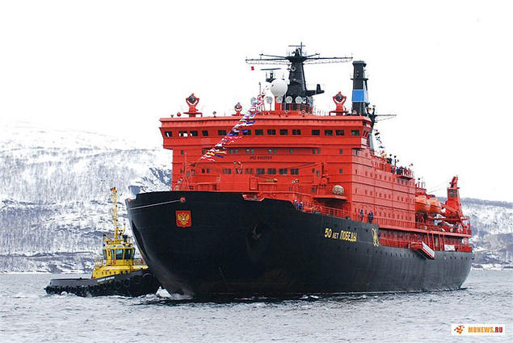The icebreaker 50 Let Pobedy, off Russia's northern coastline. Photo: Rosatom
The Russian approach towards the Northern Sea Route has long been to attract international users and transit shipping. With recent policies, however, things are heading in a different direction.
24.08.2020
This shift in strategy towards the Northern Sea Route (NSR) is analysed in close detail in an article recently published by the Polar Journal. Authored by FNI’s Research Professor Arild Moe, a long-time expert on Russian and Arctic politics, the article investigates how the principles of NSR regime, i.e. the laws and regulations governing shipping activities along Russia’s Arctic coast, have developed and changed over the past decade.

A top, national priority
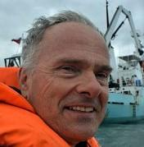
Arild Moe, FNI. Photo: Private
With its immense northern coastline, Russia obviously has far-ranging interests concerning the NSR. It remains the only way to access many areas along the coast, it offers the shortest voyage between Russia’s east and west, and significant mineral resources have been discovered or are expected in the region. Development of the NSR has thus been a key element of Russia’s Arctic ambitions. By many it has been perceived as a major factor in Russia’s efforts to re-establish itself as a world power.
The NSR has also attracted substantial international interest, as it provides a much shorter sailing route between the North Atlantic and the North Pacific than southern routes, and the lighter ice situation has made trans-arctic transits more feasible. However, it remains uncertain whether the route will in fact attract substantial traffic, and to this end, the conditions offered by Russian authorities will no doubt be of crucial importance.
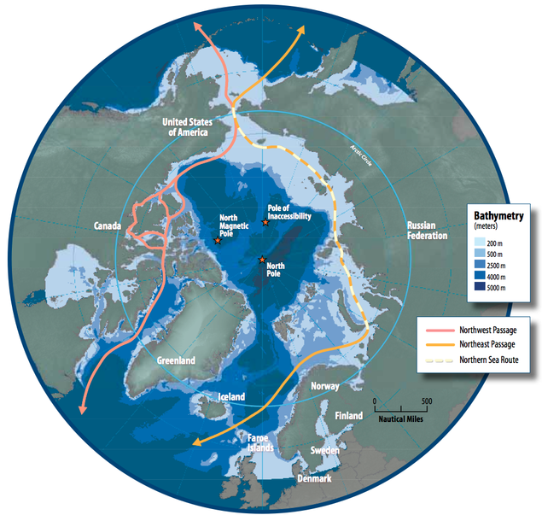
The Northern Sea Route, the Northwest Passage and the Northeast Passage. Illustration: Susie Harder, Arctic Council

Large extraction projects
As Moe demonstrates in his article, the expectations from ten years ago for a rapid increase in transit shipping along the NSR quickly faded. Instead, the development of destination shipping serving large resource extraction projects has become a top political priority. Focus is on extracting and capitalizing on the large mineral resources in the region. The NSR administration has also undergone significant change, with a dominant role accorded to the state nuclear energy corporation Rosatom – itself engaged in commercial activities. At the same time protectionist legislation has been introduced, making Russian flag compulsory for vessels transporting hydrocarbons, as well as requiring that new tankers and carriers must be built at Russian yards.
International shipping and other business stakeholders will have to adapt to a shift in Russian strategy, the article argues. As Moe writes: 'the room for foreign shipping interests has shrunk, but not disappeared. Their opportunities will depend on alliances with key Russian players.’
You can download the entire article from the Polar Journal here.
Related reading:
- Russlands Nördlicher Seeweg: Nationale Exporttrasse statt internationaler Handelsroute ('Russia's Northern Sea Route: Shipping Russian hydrocarbons in the Arctic Ocean')
- Voyage Through the North: Domestic and International Challenges to Arctic Shipping
- Organization and Management Challenges of Russia's Icebreaker Fleet
- Globalization of Russian Gas – great reviews for new book
- Asian Countries and Arctic Shipping: Policies, Interests and Footprints on Governance
Discussion In Groups Of 3 Articles
- “The role of conferences within Arctic governance”, Polar Geography, 2021: pdf available at
https://www.tandfonline.com/doi/epub/10.1080/1088937X.2020.1798540?needAccess=true

Emerging Issues on Arctic Environmental and Climate Change Governance: Introduction
https://brill.com/view/journals/estu/35/3/article-p429_1.xml?language=en&ebody=full%20html-copy1

Actors and justifications in media debates on Arctic climate change in Finland and Canada: A network approach
https://journals.sagepub.com/doi/10.1177/0001699319890902
Lesson 5
https://climatechangenunavut.ca/en/understanding-climate-change/climate-change-impact:

CLIMATE CHANGE IMPACTS

What is Climate Change Impact?
Climate Change Impact is a way of looking at the effects climate change has on the people and environment of Nunavut, over time.
Almost every part of life in the region will be touched by climate change. It’s important to be aware of these changes in order to deal with impacts that have already happened and prepare for those that will most likely take place.
For example, decreasing ice could allow increased shipping through Arctic waterways, including the Northwest Passage. While this may mean economic benefits for Nunavut, it can also raise the risk of oil and chemical spills. Increased land-use activities and natural resource development, together with population growth and an expanding economy, mean we must plan to ensure environmental sustainability in the future.

Impacts on Culture, Health and Well-being
For centuries, Inuit have maintained a close relationship with ice (siku), land (nuna), sky (qilak), and wildlife (uumajut). Inuit rely on innovative survival skills adapted to the unique climate and weather of the Arctic. Rapid environmental changes will continue to affect Inuit culture and the well-being of all Nunavummiut.
Nunavummiut are part of a complex social and environmental system. Climate change in Nunavut cannot be addressed without considering other factors. Communities’ ability to cope and adapt to climate change will be limited by factors such as housing, poverty, food security, language, modernization, and the erosion of traditional land-based skills. All of these factors have direct impacts on the maintenance of Inuit cultural identity, and the well-being of Nunavummiut.

Impacts on Traditional Activities
Many Nunavummiut depend on hunting, fishing and gathering to support themselves and the local economy in their communities. Local hunting practices have already changed and new technologies are increasingly relied upon.
Inuit elders, who traditionally used their skills to predict the weather, have observed changing cloud and wind patterns (see Voices From the Land for direct quotes from elders on the changes they have witnessed). Their weather and climate-related knowledge does not fit with today’s weather conditions and patterns. Unpredictable weather and climate has increased the risk of travelling on the land. This has made it very difficult for elders to pass along their weather prediction skills to younger generations.
Some traditional travel routes are now unreachable, preventing the use of traditional camp sites. According to many elders and community members, decreasing water levels make travelling by boat more difficult. The early melt of lakes, rivers and sea ice make travel routes unsafe in the spring, and thawing permafrost makes travel by ATV in the summertime more difficult.

Impacts on Food Security
Climate change’s projected impacts include less access to wildlife and more safety risks from changes in sea ice thickness and distribution, permafrost conditions and extreme weather events. This means traditional food security may be significantly affected.
The shift from country food to expensive, store-bought, and often unhealthy food items has had negative effects on Inuit health and cultural identity. Climate change can make this problem even worse.
Food storage is also affected by warmer temperatures and thawing permafrost. Interviews with elders suggest that outdoor meat caches, which used to remain fresh and preserved in the cold, now spoil.
Country food is still the healthiest food choice for Nunavummiut. However, climate change may increase human exposure to contaminants. A shifting climate can change air and water currents that bring contaminants into the Arctic.Also, changes in ice cover and thawing permafrost appear to have contributed to increased mercury levels in some northern lakes. This results in more contaminants making their way into plants, animals, and ultimately humans.

Impacts on Health and Diseases
Diseases that can be transmitted from animals to humans (scientists call them “zoonotic diseases”) are expected to rise as temperatures warm. Previously isolated animal species may come in contact with each other when natural barriers like ice or snow decrease from climate change. This can increase the spread of diseases.
Extreme weather and natural hazards are both direct impacts on human health from a changing climate. Unpredictable weather patterns may cause more accidents and emergency situations. Search and rescue missions are affected, as searches are often held back by these unpredictable weather patterns.

Impacts on Heritage and Special Places
Heritage and special places in Nunavut are being affected by permafrost degradation and increased coastal erosion caused by the late freezing of sea ice. The cold Arctic climate helps preserve organic material frozen in permafrost. If the permafrost changes, it will ruin cultural remains and archaeological artifacts that were previously preserved. Ongoing freeze-thaw cycles promote the decay of artifacts such as sod houses (many of which hold their form because of permafrost) and other historical resources, such as sites relating to European exploration of the Arctic. Naturally occurring coastal erosion is expected get worse as sea levels rise. This will threaten historic sites on southern Baffin Island, northern Victoria Island and the western high Arctic islands, where little archaeological surveying has been done.
Nunavut has seen more tourists who want to experience our unique Arctic environment and visit heritage sites, parks and special places. Nunavut’s historic and archaeological resources are key attractions for cruise ships and other visitors. Their deterioration can negatively impact tourism.

Impacts on Infrastructure
Over the past several decades, we have used the unique properties of frozen ground, or permafrost, to our advantage. We tailored the engineering of buildings around the characteristics of frozen ground. Permafrost presents challenges to the construction, operation and maintenance of buildings, airports, roads and other northern infrastructure.
As a result, changes in permafrost, ice conditions, precipitation, drainage patterns, temperatures, and extreme weather events can have negative results for infrastructure designed for permafrost conditions.
Permafrost thaw can cause building foundations to shift and become weak. Frozen ground provides a secure foundation. If it does not stay frozen, its strength and integrity – or ability to support a building, pipeline, road or airstrip – may be affected. Older facilities may be more vulnerable because climate change was not considered when these structures were built.
The impacts of climate change are expected to become a major burden on government resources. Municipal infrastructure impacted by degrading permafrost (for example, sinking/cracking buildings) may divert resources from building new infrastructure. Engineering and construction practices for building on changing permafrost are being developed. However, these changing practices will affect the cost of both construction and maintenance of current and future infrastructure.
Pipelines, roads and airstrips, which also rely on permafrost for structural integrity, are experiencing stresses from shifting and thawing grounds. Eventually, these will need to be repaired due to changing freeze and thaw conditions.
Although new infrastructure is being designed to suit a changing environment, existing water and waste containment facilities may not have been designed for current and future warming trends. These facilities and other naturally-occurring containment structures may fail, with possible impacts on the environment and human health.
Land-use activities contribute to changes in the structure of the ground and permafrost by altering the amount of sunlight absorption, and changing the flow of water. This can cause collapsed roadways, and shifting building foundations. Avoiding this will involve a great deal of planning to make sure that infrastructural integrity is maintained. Environmental changes and effects on permafrost are presently considered in community land-use planning and climate change adaptation plans. Current data and tools being developed will continue to provide information to design appropriate, sustainable infrastructure that works in a changing climate.

Impacts on Transportation
Decreasing sea ice thickness and cover will open areas of land and water that have been inaccessible. This will lead to more shipping and industrial activities. While a longer summer shipping season will generate more economic opportunities for Nunavut, it will also increase risks to the environment, most notably through spills and other pollution incidents.
Other transportation-related challenges have been identified. For example, sea ice changes present challenges to traditional snowmobile or dog team transportation routes. New or alternate routes will be needed to continue safe traditional hunting and recreational activities.
Degrading permafrost and changing freeze-thaw cycles have visibly shifted and cracked the surface of airport runways throughout Nunavut. This is a significant transportation challenge because air travel is a main resource for Nunavummiut to receive food and supplies.
In response to these challenges, Nunavut will need improved research, monitoring and response capabilities. This includes new and better infrastructure, mapping, and navigational systems. Improved infrastructure will likely include roads, asphalt paved runways, and fixed marine structures in coastal areas.

Impacts on Resource Development
An increase in exploration and industrial activities will likely result from current climate change projections, which include reduced sea ice cover and warmer temperatures. The Canadian Arctic Archipelago has the potential for vast hydrocarbon deposits and other mineral deposits. Oil and mineral resource development are expected to increase.
Renewable resource development, such as fisheries, will also be impacted by climate change. Fishing in Nunavut is an important part of the economy and subsistence living. It is likely that the number of fish species present in the waters off Nunavut will increase as sub-arctic species will move further north with the warming climate. Although this can result in new opportunities for fisheries, it can also bring parasites and new predators. Current and planned fisheries activities and management will need to be continuously monitored and adjusted to address the impacts of climate change.

Impacts on Tourism
Longer summers can result in an extended ‘high’ tourism season and increased tourism activity. Decreasing ice cover is likely to result in more shipping traffic, particularly cruise ship activity, into areas that were formerly inaccessible and/or had limited access. While beneficial, more marine tourism brings challenges in the form of impacts on communities, historic resources, and the environment in general. Addressing these challenges will require additional resources.

Impacts on Arts and Crafts
An increase in tourism should lead to more sales of arts and crafts, and milder weather will make access to carving stone possible for longer periods during the year. However, sudden and unexpected weather patterns and thawing permafrost can pose a risk to the safety of artists and businesses accessing quarry sites at great distances from the communities.

Impacts on Energy
The changing climate will potentially have great impacts on our energy sector. Warmer temperatures will affect our heating requirements, making it less expensive to heat buildings.
Existing power plants will be affected by changes in permafrost conditions, which will influence the stability of infrastructure. Settling of foundations in existing power plants has already been noticed. Degrading permafrost is also expected to impact fuel tank farms and transmission lines. For example, permafrost degradation has created conditions where hydro poles are easier to install. At the same time, degradation is also responsible for destabilizing poles, causing them lean precariously because of weaker soil
Changes in water and precipitation patterns along with permafrost degradation may impact hydroelectricity development. Previous studies that estimated hydroelectric potential will no longer be reliable as the flow patterns in our lakes and rivers may change as a consequence of climate change. Some studies have suggested that precipitation will increase, which can have a positive effect on the amount of water available for hydroelectric power production. Possible changes in wind patterns may affect the feasibility of wind generation.

https://www.canadiangeographic.ca/article/its-time-listen-inuit-climate-change:

It’s time to listen to the Inuit on climate change
Because temperatures in the Arctic are rising faster than anywhere else in the world, we must look to the experiences of Inuit as a harbinger of what is to come — and seek their guidance on how to live sustainably
- 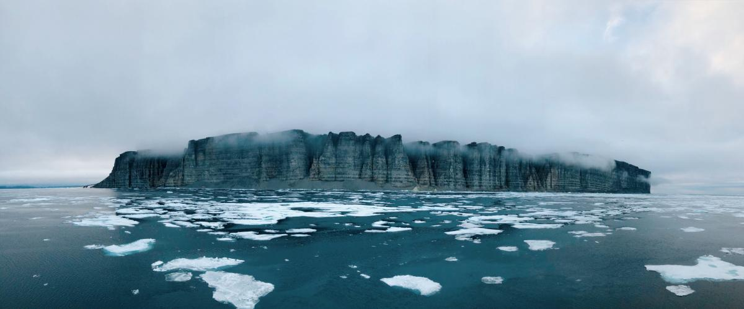
When it comes to climate change, what happens in the Arctic does not stay in the Arctic. (Photo: Andrew Lovesey/Canadian Geographic)
- Previous
- Next
By Sheila Watt-Cloutier
November 15, 2018
When other regions of Canada and world are struck with major environmental and natural disasters, communities, first responders and the media rush to their aid. Not so for the Inuit and other Indigenous peoples of our country, who have already experienced life-threatening emergencies on many levels, and are now at the front lines of the slow, multifaceted disaster that is climate change. Because temperatures in the Arctic are rising faster than anywhere else in the world, we must look to the experiences of Inuit as a harbinger of what is to come, and seek their guidance on how to live more sustainably.
Virtually every community across the North is now struggling to cope with extreme coastal erosion, thawing permafrost, and rapid destructive runoff, which particularly affects coastal communities in Alaska and in northern and western Canada. Despite our cold northern winters, sea ice remains in rapid decline. Glacial melt, long relied on for drinking water, is now unpredictable. In one stunning case, the Kaskawulsh Glacier in the Yukon has receded so far that its meltwater has changed direction, flowing south toward the Gulf of Alaska and the Pacific Ocean instead of north toward the Bering Sea. Ice that used to serve as our winter highways is giving way and invasive species are travelling much further north than ever before. While the impact and extent of each change varies across the North, the trends are consistent. The change is not just coming, it is already here.
Melting Arctic ice has also attracted the attention of foreign governments, researchers and corporations who see an opportunity to access its wealth of resources. But, this interest has to be better informed by awareness of what is happening to Indigenous communities, who are trying to cope with the grave reality of their changing environment.
Recently, the United Nations Intergovernmental Panel on Climate Change (IPCC) issued a special report on the impacts of global warming 1.5°C above pre-industrial levels. The report paints a stark picture: humans have already caused approximately 1.0°C of global warming and without an immediate and concerted effort to reduce greenhouse gas emissions, the 1.5°C threshold will be reached sometime between 2030 and 2052. In order to arrest this dangerous trajectory, the world has to take note of what is happening in the Arctic — because what happens in the Arctic does not stay in the Arctic. Arctic ice is the planet’s air conditioner; as it melts, that air conditioner is breaking down, creating havoc around the world.
Since then, environmental advocates around the world have sought to protect human rights affected by dangerous climate change through various kinds of legal proceedings. Given that the United States is walking away from the Paris Agreement and other governments have been slow to act, recent cases in the Netherlands, Colombia and the United States suggest that climate litigation may increasingly be seen as an essential tool to protect human rights and to safeguard the environment.
Although it can be hard for individuals to grasp the urgency of the situation, make no mistake: climate change will negatively impact our quality of life. Asserting this human perspective could help to spur action where other approaches—such as highlighting only the impact on wildlife like polar bears and coral reefs—have not yet achieved sufficient results. Inuit have much wisdom to share with the world about living sustainably, in harmony with nature—all while coping with the effects of climate change.
Inuit and Indigenous peoples provided life-saving guidance to early European visitors unfamiliar with the severe conditions of this land, which they ignored at their peril. The whole planet benefits from a frozen Arctic and Inuit still have much to teach the world about the vital importance of Arctic ice, not only to our culture, but to the health of the rest of the planet.
Sheila (Siila) Watt-Cloutier is a senior fellow at the Centre for International Governance Innovation, a 2007 Nobel Peace Prize nominee and author of the acclaimed book The Right to Be Cold, published in 2015. She is Inuk and one of the most widely respected political figures to emerge from the Arctic.

https://www.erudit.org/en/journals/etudinuit/1900-v1-n1-etudinuit3992/045403ar/

Inuit perceptions of climate change in East GreenlandPerceptions inuit du changement climatique dans l’Est du Groenland

Online publication: Jan. 25, 2011
URI
https://id.erudit.org/iderudit/045403arCopiedAn error has occurred
DOI
https://doi.org/10.7202/045403arCopiedAn error has occurred

Abstract
Global warming and climate change are important topics of debate in Greenland. This paper examines how the Tunumiit of East Greenland perceive the weather, the changing climate, and the local environment. It also discusses how their perceptions have been influenced by political debates on global warming, sustainable development, and wildlife management since the 1950s. In the past, if some animal species disappeared from a specific area, or if the weather turned bad, the Tunumiit would attribute this misfortune to human transgressions of rules of respect. Today, they often connect the increasingly unpredictable weather to their reduced access to natural resources and greater difficulties in travelling. Some hunters speak of a shift from seal hunting to cod fishing in East Greenland, although fishing is still perceived as a vulnerable source of income with low status. Nowadays, older methods of navigation and orientation coexist with such new technologies as GPS and mobile telephones. Some local hunters and villagers feel unfairly accused of increases in CO2 emissions and pollution from their motorboats and generators. Tunumiit hunting communities are facing increasing uncertainty on all levels of their existence, and their hunters are turning to the growing tourism industry—a side effect of global warming—and other coping strategies to maintain their local subsistence activities and to reinforce their own culture.

Introduction
East Greenland was “discovered” in 1884 when its population numbered about 400 people (Thalbitzer 1914: 27). In 1894, the first Danish trading post and missionary station was established in Tasiilaq (Ammassalik) (Eistrup 1989: 97). Today the Tasiilaq District has ca. 3,000 inhabitants. The municipalities of Nuuk, Tasiilaq, and Ittoqqortoormiit merged in 2010 to become Sermersooq Municipality. During the 1960s, Tunumiit[1] families still spent their summers in tents scattered in small groups along the fjord. A nuclear or extended family inhabited each tent, and several families formed compounds of up to five tents. They moved along the coast, forming ever-changing groups that gathered together in winter in relatively big winter dwellings and at midsummer for summer fishing. They exchanged news and shared meals. Men went out hunting together, and people celebrated with drum dances, games, and other festivities (Nooter 1976; Petersen 2003; Robbe 1994; Robert-Lamblin 1986; Rosing 1957).
This lifestyle was changed during the second half of the 20th century by the Danish government’s centralisation policy (G60). New settlements were built along the fjords. Danish workers constructed prefabricated two-room wooden houses and the Inuit were advised to settle in permanent villages. Centralisation was intended as a means to provide social services, schools, churches, small stores, and local medical stations. The result was abandonment of the smaller settlements in East Greenland. The population had to be concentrated as a prerequisite for the introduction of large-scale fishing techniques, fishing vessels, and fisheries. The East Greenland economy shifted from subsistence hunting, fishing, and gathering to a cash economy. Hunters’ families began to augment hunting yields with other sources of income, and many East Greenlanders found paid employment. Strong cultural continuity continued into the second half of the 20th century and, even today, several families camp on the land during the summer months. The summer migration now takes place during school holidays and still involves subsistence activities on the land, such as fishing and hunting. It is still important to the economic and social life of the Tunumiit in small settlements (Dahl 2000; Petersen 2003).
Even today, although many people have paid jobs and scheduled working hours, the pace of life is different during winter and summer. The winter solstice coincides with the celebration of Christmas and New Year’s Day, and the summer solstice with the National Holiday of Greenland, on June 21. Climate change has not affected the summer and winter pattern of the Tunumiit, although summers and winters are now somewhat warmer on average.[2] Summers are a bit longer and winters somewhat shorter. The changes are most obvious during autumn, which now lasts longer, and spring, which comes earlier.[3]
Global warming and climate change are major topics of debate in Greenland. Greenlanders are aware of climate changes and global warming discourse. For more than a decade, several studies have thoroughly examined Inuit perspectives on the environment (e.g., MacDonald 1998; Sejersen 2002, 2003) and on climate change (e.g., Berkes and Jolly 2001; Krupnik and Jolly 2002). However, it was the 2007-2008 International Polar Year that generated the most research on Arctic communities and their strategies for adapting to the changing climate (e.g., Smit et al. 2008). Nonetheless, the political elites usually ignore Inuit perceptions of climate change, and Indigenous knowledge is often looked down upon by the policy-makers and natural scientists. This article explores how the Tunumiit now interpret climate change in East Greenland and the rapid developments in their environment. I gathered the data from the hunting communities of Tasiilaq and Tiilerilaaq in 2007 and 2008, via participant observation and 25 open interviews with 14 men and 11 women, 41 to 82 years old.

Changes in the weather
The climate has never been stable in East Greenland. During the 1960s, the temperature of the seawater off the East Greenland coast changed, and when the Dutch anthropologist Nooter began to study the hunting culture of the Tiilerilaarmiit in 1965 hunting conditions had changed, too. During a relatively warm period between 1930 and the 1960s, the cod population increased and subsistence activities in East Greenland shifted from a predominance of hunting to more profitable fishing. When Nooter returned to the same area in 1967 the situation had changed again: water temperatures had dropped and people in Tiilerilaaq had returned to a predominantly seal-hunting economy. Greenlanders are used to adapting to their changeable environment.
East Greenlanders informed us in 2007 and 2008 that in 1985 the Sermilik fjord was still covered with a solid layer of ice during the winter, unlike winters in the 1970s and 1980s when the ice was often blown away. East Greenland is known for heavy storms called neqqajaaq and pilarngaaq. The ice on the fjord would disappear after the storms and then build back up. After a few days, there would be a resumption of seal hunting at the breathing holes and on qatsimalit (‘seals basking in the sun on the ice’), as well as dogsledding (cf. Poort 2007: 93ff.). Although the climate has never been stable, it is now described as “not normal” by Marius Nakinge:
The last winter that the ice on the Sermilik fjord was still closed predominantly during the winter was in 1982. From that year onwards we have now become aware of a trend toward open water during the winters. Nowadays, the Sermilik fjord has open water until February, and for many winters from ca. 1997 onwards it has been possible to sail by motorboat the entire winter. This was not normal in the past. We used to drive much more by dogsled. The situation is very unusual. Sila[4], the weather, is unpredictable nowadays.
Marius Nakinge, 2007
The Tunumit observe that sea ice now appears later in winter and disappears earlier in spring. They see that fjords previously covered with ice in October or November may nowadays not freeze before December, or even as late as January or February. Until about 1982, the ice used to break up in the month of May. Hunters relate that nowadays it breaks up a few weeks earlier, and is already unreliable in March. Ice on the fjords is thinner than in the past, and there are winters with unusual amounts of snow. This combination is dangerous as people in Tasiilaq and Tiilerilaaq explained:
There is nowadays more snow than in the past. Sometimes two metres or more. Thin ice covered with a thick layer of snow is very unreliable. Just going out on the ice to go ice fishing for suluppaavaq (‘ocean perch,’ Sebastes marinus) is not possible anymore.
Paulus Larsen, 2008
One person takes the lead and the others follow him at a safe distance.
Augo Kristiansen in Sjouwerman 2009
Some dogsled and snowmobile routes have changed because of bad ice conditions. People often say that the weather has become unpredictable with more storms and rain, and this perception is corroborated by data from the Tasiilaq weather station.
Perceptions are also being influenced by modern communication technology. The local radio station broadcasts weather reports and predictions hourly. Hunters and fishers in motorboats have since the 1980s used radio equipment to listen to the weather broadcasts. They communicate by mobile or radio telephones. Some East Greenlanders also use GPS nowadays when travelling by boat, but not all of them can afford it. Older systems to indicate direction and position still exist and even today Tunumiit are very specific in indicating where a person, a boat, or an animal is (cf. Robbe 1977: 74-77). East Greenlanders travelling in small motorboats often only have a mobile telephone, while owners of bigger motorboats (poortuleerngat) and cutters, which are less used nowadays, have radio equipment. There is less use of modern communication technology during winter snowmobile or dogsled journeys, due to a limited range of service.[5] However, use of modern communication technology is rapidly developing (e.g., Dahl 2000), and the Greenland Self-Government is also investing in Internet communication.
There is still extensive traditional knowledge of the weather, sailing routes, sea currents, tides, ice conditions, and iceberg movements, as expressed by this woman:
Kangeqlusuaq fjord is a long strait through which we sail along the way from Tasiilaq to Tiilerilaaq. The route is situated to the east. Here it is always blowing. Storms are so heavy here that usually Kangeqlusuaq does not freeze in winter. There is always open water here. We now have heavy storms, nerqqajaaq, during September and October. We had that in the past, too. East Greenland is known for its stormy weather, but during the last few years there have been more storms and heavier wind. So often we cannot sail through Kangerlusuaq […]. The current is heavy during strong wind. Because of the long distance of this strait, the wind creates long bulges. Our motorboats go up and down a lot and we take on much water. In an open motorboat, we get wet entirely. For us women and children in the boat, it is too much. We become cold and frightened and it hurts because you are thrown upward and smashed back in the boat again. Aqa, it hurts! Sometimes it is really dangerous and it is not possible to travel by boat. So now we cannot go through Kangerlusuaq but we cannot go back either. We will try to reach Kulusuk. Here my husband has family and we can stay overnight.
Silipa Ignatiussen, 2008
Traditional knowledge is combined with modern technology and scientific knowledge. Many Tunumiit referred to the retreat of glaciers in the area. Pointing out the window to a glacier that is part of the inland ice, Sakaeus Taunajik (2007) stated: “Now the glacier is small, you can see it. In the past the glacier was much bigger and came all along that spot over there. You can see it every year, the ice is melting and the glacier becomes smaller and smaller. The glacier will soon disappear.”

Animals, subsistence activities, and climate change
Several types of marine mammals frequent Greenland’s East Coast. Ringed seals prevail in the Tasiilaq area and are found all year-round. Bearded, hooded, and harp seals, as well as narwhals are common from early summer to autumn. Polar bears roam around a large area and are seen occasionally. Walrus and mink whales are scarce, with only a few individuals seen every year. Arctic foxes are the only land animals seen frequently. Caribou were still seen in the 1980s but have since disappeared. Birds such as fulmar, eider, ivory gull, and black guillemot are seen in relatively large numbers (Glahder 1995: 74; Hovelrud-Broda 1997; Robert-Lamblin 1986; our 2007 and 2008 interviews). People in East Greenland informed us that they had witnessed climate changes and their effects on animals living in and migrating to their environment.
Hunting and fishing costs have escalated with the introduction of Western technology. Cash income, required to meet these needs, comes from hunting, fishing and, increasingly, paid jobs.[6]To obtain hunting licences, hunters must apply to the municipality, which decides on the applications in cooperation with the association of fishers and hunters (KNAPK). Each year, it is necessary to renew the two types of licences—one for professional hunters (piniarteq), usually full-time hunters, and the other for recreational hunters (sunngiffimiaallaniartoq), usually part-time (weekend) hunters who combine hunting with a paid job.[7]
Hunting families currently sell most of their sealskins to the Pilersuisoq A/S trading company. Only a small portion is still used for domestic purposes, such as making garments (Buijs 2004: 245-246). In East Greenland the majority of seals are ring seals.[8] The seal hunt is still of economic and cultural importance, especially to families living in small settlements such as Tiilerilaaq, where almost every household has at least one hunter. Each household is connected by family ties to other households who still depend partly on hunting and fishing for their income. Sealskin prices depend on size and quality. The skins are measured and judged by local officials at the small Pilersuisoq offices in the settlements and at the Pilersuisoq office in the district capital, Tasiilaq. Because of the difficult position of sealskin on world markets, the Greenland trading company has developed strict quality standards for sealskins. Skins of poor quality, such as those of moulting seals, have not been accepted since the early 1990s. Skins with many scratches or mended bullet holes are assessed as low-quality and fetch a lower price (Buijs 1986, 2004: 246; Hovelsrud-Broda 1997; Robbe 1975). Pilersuisoq does not sell these skins on the open market, but delivers them to the private company Great Greenland in Qaqortoq, South Greenland. The majority are processed by the Great Greenland tannery, which then sells tanned and painted sealskins to sewing workshops all over Greenland, and some to Denmark.
World market prices for sealskins fluctuate. Actions against seal hunting and boycotts of the sealskin trade by animal welfare organisations such as the WWF (World Wildlife Fund) and Greenpeace have hurt the prices of commodities produced by Greenlanders. After intensive anti-fur campaigns in 1967, 1977-1978, and again in 1982, sealskin prices dropped dramatically (Wenzel 1991). The Greenland Home-Rule Government decided to keep sealskin prices artificially high, so hunting was and still is subsidised (Buijs and Nooter 1987; Lynge 1992; Nooter 1984). In 2001, hunters were paid an average of DKr 297 for a sealskin (Grønland Kalaallit Nunaat 2003: 471, tables 5.5 and 5.6; Hovelsrud-Broda 1997, 2000).
If the seal species depends on the ice to rest or to make dens for its young in spring, it is especially affected by climate change in East Greenland:
Thin ice has consequences for some of the seals. When the female seals have to give birth, they make a den in the snow on the ice. Here the baby seals have a safe and warm place. During the first period they cannot swim and the water is too cold. Often the young seals fall through the thin ice. In spring I see young baby seals swimming, squeaking for their mother, while they should still lie in their dens. Their woolly down soaks up the water and they become too heavy and drown.
Augo Kristiansen in Sjouwerman 2009
A hunter from Tiilerilaaq explains that the yields from seal hunting are decreasing: “Usually, I catch about 200 seals a year. There are not as many seals anymore. Last year I caught only 100 seals” (Marius Nakinge, 2007). However, many hunters report an increase in seals “due to change in the amount of pack ice coming into the Sermilik fjord from the south” (Poort 2007: 93, 98ff). Cod has come back to the fjords of the Tasiilaq district, and some of the hunters now catch more fish and fewer seals: “Cod fishing and salmon and trout fishing are becoming more profitable. The water is warmer nowadays and there is more fish, and the fish are bigger. The cod has come back. I think I will shift to fishing instead of hunting. The Europeans do not want our sealskins any more. So maybe it is better to fish” (Paulus Larsen, 2008).
Polar-bear hunting also has always been economically important to the Tunumiit. The number hunted in East Greenland is quite low and regulated by means of a quota set nationally by the Self-Government (about 10 to 15 polar-bear skins are sold annually to Pilersuisoq). The value of polar-bear pelts has always been considerable.[9] Since this population is under pressure by the retreat of the pack ice along Greenland’s East Coast, the polar-bear hunt has become highly controversial.[10]The WWF and Greenpeace are striving for a total ban. They are also targeting trophy hunting by American tourists who are willing to pay high prices to hunt with a local hunting guide. They hire an acknowledged full-time hunter with a green full-time hunting licence to find polar bears and to escort the tourist on the hunt. Tourists are officially forbidden to shoot polar bears without special permission. Trophy hunting is not practised in East Greenland, and is debated among the hunters and their families in Tiilerilaaq and Tasiilaq. Some hunters stress the advantages of earning “big money” and their vulnerable economic position as hunters. Others maintain that hunting polar bear is part of the culture and tradition, and only great hunters, piniarteqsuaq, are able to hunt a polar bear. “These Americans have no rights to be here. Full-time hunters themselves need the polar-bear hides to earn money and make a living” (Sakaeus Taunajik, 2007).
Like the biologists, some hunters report that the number of polar bears is decreasing (Poort 2007: 68-69), while others state that they have seen more of them lately:
Probably polar bears now come close to the villages because they are hungry. A polar bear was seen at the garbage dump the year before. In the newspapers there was mentioned this case on the West Coast, when a child was approached by a polar bear near the coast. The infant’s mother could not reach her child. Fortunately the polar bear was shot in time.
Aviaja Philbert, 2008
In general, however, the biologists differ with the Tunumiit on the sizes of animal populations,[11]and the two parties have different views of nature. One hunter in Tiilerilaaq stated:
The Danish biologists come here and they count the animals, but they only visit the area one summer. Sometimes they fly around in a helicopter and count narwhals from the air. They say that the population is declining. But we see that there are still many narwhals. It is the same with the polar bears. We do not see fewer polar bears around here; we only catch fewer due to the reduced quota. I do not know, maybe we are wrong, maybe the biologists are wrong. They do not listen to us and they never ask us about the animals. They respect neither our culture nor us. They never ask us about the animals and we are the ones going out every day, living here the whole year. When they do listen, they do not take our answers seriously. Even our politicians in Nuuk listen more to the biologists than to their own Greenlandic hunters.
Hans Jonathansen, 2008
When outsiders such as Danish employees, scientists, journalists, tourists, NGOs, wildlife management organisations, and environmentalists apply their Western norms and values to Greenland’s situation, they are insufficiently aware that they stem from a different culture. Sometimes their calculations and opinions do not differ so much from Indigenous observations (see Poort 2007: 93). But local opinion is being ignored. Tunumiit want to be heard and participate in research and debate. More outsiders now travel to Greenland, since the country has attracted so much attention in the climate change debate:
The entire world is looking at Greenland nowadays, because the ice and glaciers are melting. We are fed up with them, especially with Greenpeace. We don’t want them here. Why are these people coming? Let them stay at home in their country. […] It is not their country. We want to live in peace and live our lives as we always have done. We want to make our own decisions. We do not impose our ideas on them. We are not that kind of people.
Sakaeus Taunajik, 2008
Another impact of climate change is that travel is more difficult. This affects daily life as well as hunting and fishing:
When winter comes, we sail with our boats through 10 centimetres of ice. Greenlandic boats are reinforced but they are not designed as icebreakers. Sometimes the ice causes holes in our boats. Therefore, I prefer to drive a dogsled in winter. Because of the thin ice, hunting by dogsled is more dangerous. Now we have to struggle with our boats through the ice. This is difficult and takes a lot of time while the winter days are short.
Julius Nielsen in Sjouwerman 2009
Some routes can no longer be traversed by boat, dogsled, or snowmobile:
In the past, my daughter and son-in-law came by snowmobile from Tasiilaq to visit me [in Tiilerilaaq]. They always took lots of bags with them with shopping for me. I got bread, apples, potatoes, onions, and other things that are rapidly sold out or not available here at the village shop. But the snowmobiles can no longer cross the ice just outside Sarpak. And also the other way round is not reliable anymore. There is hardly any winter when the ice is strong enough for the snowmobiles. I do not see my daughter from town often anymore. The helicopter is too expensive to take regularly.
Domilia Kristiansen, 2007
It takes longer to manoeuvre a boat through the ice and to find new safe routes by snowmobile. Hunters complain of longer travelling distances, which raise their expenditures on fuel for motorboats and snowmobiles. Hunting yields are decreasing, whereas those for fishing are increasing. Some Tunumiit hunters have shifted from seal hunting to cod fishing. Fishing, however, is perceived as a hazardous source of income and a low-status activity.

Local and governmental views about climate change in East Greenland
Today, when the Tunumiit meet—at home, at the local store, during hunting trips, or at work—they talk about climate change. Greenland’s newspapers provide information on the weather, as well as on long-term predictions for climate change and global warming. Greenlandic and foreign television programs broadcast information on melting glaciers, the decreasing size of Greenland’s ice cap, changing patterns of wind and sea currents, and developments with the ozone layer and other atmospheric phenomena. Greenlanders follow the news on expanding desserts in Africa and on rising sea levels that may cause serious problems in such low-lying coastal areas as Bangladesh and the Netherlands.
However, East Greenlanders wonder about the accuracy of information on climate change. Although some people doubt that the climate is warming up, the majority acknowledge changes in the environment. They see transformations in weather patterns, snow and ice formation, and sea currents off East Greenland’s coast. Some people in Tiilerilaaq state that climate change is caused not by humans, but by the will of God. Others mention the natural processes of Sila as the main reason and are not certain about human influences.
Some Tunumiit see climate change as a consequence of human pollution. Exploration for gold, platinum, and palladium started in 1986, and the hunters north of Tasiilaq discuss its impact on wildlife. They also refer to pollution caused by the American military base established at Ikkatteq in 1942 and abandoned in the 1950s, which left corroded metal containers that are still scattered around. The effects of pollution of the seawater are also often mentioned, especially near the harbours of Tasiilaq and Tiilerilaaq, and the coastal waters off Tasiilaq. Hunters complain of a “plastic soup” drifting up and down the coast with the tide. They relate that seals and narwhals are scared off by motorboats, ships, low-flying helicopters, and noises from the land, such as car traffic, drilling, and explosions from building activities in the town of Tasiilaq. Paradoxically, some local hunters and villagers feel unfairly accused of increases in CO₂ emissions and pollution from their motorboats and generators:
We travel by motorboat and snowmobile. Every village has its own generator and every single house is heated privately. In the settlements you still find oil-heated stoves, which are said to be extremely polluting. This is not true. We live with so few in the settlements. The 150 people in Tiilerilaaq are not extremely negative (ajerpoq) about climate change.
Paulus Larsen, 2008
Greenland’s government stresses climate change as a challenge with new possibilities for the country. Plans to reopen some of Greenland’s mines will increase CO₂ emissions, whereas Denmark’s policy is to decrease the use of fossil fuels and greenhouse gases. The last few years have seen increased regulation to ensure sustainable use of Greenland’s natural resources and wildlife (e.g., Sejersen 2002). Hunters are affected by the many new regulations, quotas, and laws on wildlife management for more than 10 species:
We are no longer allowed to shoot eider ducks. However, there are lots in the area. The government is preventing us from hunting. They want us to move to town, to leave the villages. They want us to be modern. The small settlements are too expensive, the government says. The politicians are making our lives difficult.
Tobias Ignatiussen, 2008
To make a living from hunting and fishing, many now choose to combine traditional subsistence activities with being a tourist guide.
I ask tourists who sail with me if they will allow me to shoot a seal. Some tourists are scared of that. Some people feel sorry for the seals to be killed. They don’t like hunting. Many tourists are Ok; they say it is OK. They are really nice people who want to see how the life of a real Greenlander is,—we are Eskimo, you know—they want to experience it.
Gerti Jonathansen, 2007
With growing concern over the impact of climate change in the Arctic, there has been an increase in tourism in East Greenland. Tourists come from Europe and America to witness the melting ice and disappearing glaciers. Journalists increasingly visit Greenland to report on the impact of climate change and global warming on sea ice, glaciers, sea level, ocean currents, wildlife, and so on.

Effects of climate change on the roles of men and women
Climate change means less access to animals and forces hunters’ families to find new sources of income. Also, modernisation is marginalising the place of hunting in the economy. Some women prefer to move to town and find jobs, while some hunters want to keep their wives in their home villages, where their assistance is needed (Van Voorst 2008). As many families find it hard to make ends meet in the small villages, women often look for opportunities to earn extra money. Some women sell homemade souvenirs to tourists, such as miniature sealskin boats as key rings. Other women, especially those with some education, persuade their husbands to move to Tasiilaq, where there are more employment opportunities. However, their husbands, hunters by training, often lack the necessary education to find a proper job in an urban environment. Sometimes they find a job as a carpenter or cleaner. They often stop hunting when they move to Tasiilaq and their economic position remains precarious. Women seem to be doing better in an urban environment, and traditional gender patterns are consequently strained (Dahl 2000; Van Voorst 2008: 58-64). Being a hunter’s wife has always been an honourable position. An interviewed woman was proud to be the wife of a very successful hunter, tourist guide, and partner in a joint venture:
I earn money as an extra income, but we earn also a lot of money from the tourists. And my husband is really a piniarteqsuaq (‘great hunter’). He knows where the animals are. He has a very fast motorboat, so he can reach the very distant places where he expects seals to be around. He decides where to go and he decides when we leave. We have a lot of money. […] I stopped working at the children’s home. Having a paid job and preparing sealskins and helping my husband, travelling with him, taking care of the children, it is too complicated, it is too much work. I am happy being a hunter’s wife.
Silipa Ignatiussen, 2008
One talented Tunumiit artist, who knows East Greenland’s culture and history, sees the position of hunters’ wives differently and emphasises their hard lives: physically heavy tasks, too much work, coping with housekeeping, raising children, cooking, preparing skins, and butchering the seals their husbands bring in (Gideon Qeqe, 2008).

Conclusion
There is a wide spectrum of scientific data, ideological arguments, and positions in the debate on climate change. Much attention has been paid to adaptation and coping strategies, alternative resources, and changes in regional and national economies. Specific analyses, like this qualitative case study on values and norms related to climate change in East Greenland, can help us understand its impact on the local level. This article discussed how the Tunumiit have perceived the weather, climate change, and the local environment since the 1950s, and how their perspectives have been influenced by scientific and political debates on global warming, sustainable development, and wildlife management. Some Tunumiit speak of the direct impact of changes in resource access on their subsistence economy. Difficulties in travelling, safety issues, and accidents often result from increasingly unpredictable weather. Tunumiit observe the influences of climate change on wildlife, as well as alterations in hunting and fishing conditions. Some hunters speak of a shift from seal hunting to cod fishing in East Greenland, although fishing is still perceived as a vulnerable source of income with low status. Others expect fewer seals in a future with less ice.
Indigenous knowledge is often said to be under pressure. Hunting success in the Tasiilaq and Tiilerilaaq communities previously depended on experience, skills, and good relationships with the spirits and the game. The rules had to be observed and the game respected to ensure a proper distribution of animals and to bring good weather. Above all, the environment and humans had to be in balance. More people nowadays work in paid office jobs and fewer travel by dogsled or snowmobile; they are thus more limited in traditional knowledge, while a younger generation has learned to use new technology, the Internet, and GPS. Older ways of travel, navigation, and orientation are being combined with new technology and scientific knowledge.
Climate change and the perceptions of its effects on animal life are highly politicised. International cultural politics is influencing the situation in East Greenland in the seal-hunt debate. According to the Tunumiit, Greenpeace’s involvement as their main antagonist exemplifies this politicised external influence on the local level. There is a growing demand among Tunumiit to make their own choices and to take a stand against Euro-American dominance. It found its apotheosis in the election and realisation of Self-Government in Greenland in 2009. There is also tension in Greenland politics between the centre and the periphery. Tunumiit hunters experience more rules and regulations to protect wildlife species (quotas) and limitations on hunters (more restrictions on granting of hunting licences). The costs of sustaining the settlements, an ongoing debate in Greenland politics, are a cause for concern, as people fear that their villages are going to be closed in the future.
Climate change can hardly be separated from its effects on everyday life in the social, economic, and political domains. This interconnectedness has also arisen during the anti-sealskin campaigns of the last few decades. The most economically vulnerable areas are the ones most threatened by climate change, whereas the more successful areas and prosperous segments of society are better positioned to adapt to changes. On the national level, climate change probably means future economic opportunities. In this fast-changing environment, a new balance between “inside” and “outside,” between Greenlandness and globalisation, is developing. The Tunumiit hunters are well aware of being literally and metaphorically on thin ice.

Appendices

Acknowledgements
This article would not have been possible without the support of the people of Tasiilaq and Tiilerilaaq through their help and open communication for many years now. I wish to thank Aviaja and Mads Philbert, Thomasine Tarkissimat, Thomasine Umerineeq, and Tobias and Silpa Ignatiussen for their hospitality and friendship, and Sakaues Taunajik for helping me to translate some of the interviews. The members of the Dutch Research Group on Circumpolar Cultures, especially Jarich Oosten, gave their feedback on the article. Nola Caffey corrected my English. The financial support from the National Museum of Ethnology in Leiden, Netherlands is gratefully acknowledged. My colleague Herman de Boer is acknowledged for filming some of the interviews on climate change and for his enthusiasm during the preparations of an exhibit on climate change in the Arctic in Leiden, in 2007-2008. Making room for Inuit interpretations and native voices in the exhibit was for me one of the highlights of museum work in recent years.

Notes
- [1]
The Tunumiit include the Tiilerilaarmiit and the Tasiilarmiit. In this article I will follow the orthography of Tunumiisut, the East Greenlandic language, provided by Robbe and Dorais (1981) as there is still no fixed modern spelling. The original orthography is used in citations that I have translated from Dutch, Danish, and East Greenlandic.
- [2]
The average temperatures in East Greenland are -7.5 degrees C in winter and 5.5 degrees C in summer. The average annual temperature is -1.7 degrees C, measured during the period 1961-1990 (Box 2002).
- [3]
This information comes from participant observation and open interviews.
- [4]
The word Sila is a commonly used Tunumiisut word for ‘weather’ and ‘universe’ (Robbe and Dorais 1981: 103, 125-126; Thalbitzer and Holm 1914). It also means ‘outdoors,’ while silami is ‘being outside,’ and silamu ‘going out.’ Silaanaq means ‘air’ and ‘atmosphere.’ Sila also refers to intelligence and mind (synonymous with iisimmaseq). A person said to be silalivoq is perceived as intelligent. Losing one’s reason is silaarngippoq.
- [5]
Tasiilaq Municipal Weather and Radio Station (pers. comm. 2007).
- [6]
In 1994, 23% of the income in the village of Isertoq came from hunting; 35% from institutional transfers, and 42% from wages (Hovelsrud-Broda 1997: 85, 100).
- [7]
In 2000, East Greenland had about 400 registered hunters, 141 full-time hunters, and 254 part-time hunters; in Tasiilaq there were 45 full-time hunters and 133 part-time hunters registered; in Tiilerilaaq respectively 16 and 17 (Tasiilaq Municipality, pers. comm. 2001).
- [8]
The number of sealskins at Pilersuisoq increased between 1995 and 1999, decreased a little in 2001 and 2002 and has been stable since 2003 (Buijs 2004: 245-247; Grønland Kalaallit Nunaat 2003: 471; Hovelsrud-Broda 1997).
- [9]
One metre of best-quality polar-bear skin costs DKr 3,465. For a ca. 2.5 metre polar bear this makes ca. DKr 8,663 (Pilersuisoq 2001; cf., Grønland Kalaallit Nunaat 1996: 462, tables 5.3 and 5.4; Robert-Lamblin 1983: 320).
- [10]
According to studies by biologists, the sea ice is increasing and retreating from the coast. Polar bears can no longer swim to the ice sheets drifting in the sea and are stuck on the land and in the fjord areas. Therefore they have fewer opportunities to hunt seals. Many polar bears are losing weight and part of the population probably produces fewer offspring. The Landstinglov nr 11 and 12 om fangst og jagt (‘Parliament’s laws 11 and 12 on catch and hunt’) were revised in 2001 and are more restrictive for hunting of animal species under quota (endangered species). Hunters must be registered in Greenland for the last 10 years, be connected to Greenlandic society, have paid taxes for the last two years, and have a gross income from hunting/fishing of at least 50% (Grønland Kalaallit Nunaat 2003: 111).
- [11]
Animal species in East Greenland and their changing migration routes were studied by Glahder (1995).

References
- APORTA, Claudio, 2005 From map to horizon; from trail to journey: Documenting Inuit geographic knowledge, Études/Inuit/Studies, 29(1-2): 221-231.
Google Scholar
- BERKES, Fikret and Dyanna JOLLY, 2001 Adaptation to Climate Change: Social-Ecological Resilience in a Canadian Western Arctic Community, Conservation Ecology, 5(2) (online at: http:// www.consecol.org/vol5/iss2/art18).
Google Scholar
- BOX, Jason, E., 2002 Survey of Greenland instrumental temperature records: 1873-2001, International Journal of Climatology, 22(15): 1829-1847.
Google Scholar
- BUIJS, Cunera, 2004 Furs and Fabrics. Transformation, Clothing and Identity in East Greenland, Leiden, Research School CNWS, School of Asian, African and Amerindian Studies, CNWS Publications, Mededelingen van het Rijksmuseum voor Volkenkunde, 32.
Google Scholar
- BUIJS, Cunera and Aartjan NOOTER, 1987 Skindboykottens konsekvenser for et fangersamfund i Østgrønland (‘The consequences of a sealskin boycott for a hunting community in East Greenland’), unpublished report translated into Danish by Bente Straatman-Cortsen.
Google Scholar
- DAHL, Jens, 2000 Saqqaq: An Inuit hunting community in the modern world, Toronto, University of Toronto Press.
Google Scholar
- EISTRUP, Jette, 1989 Baggrunden for østgrønlands kolonisering, gennemførelse konsekvenser – Et bidrag til en analyse (‘An analysis of the background and consequences of East Greenland’s colonisation’), unpublished report.
Google Scholar
- GLAHDER, Christian, 1995 Hunting in Kangerlussuaq, East Greenland, 1951-1991, An assessment of local knowledge, Meddelelser om Grønland, Man & Society, 19.
Google Scholar
- GRØNLAND KALAALLIT NUNAAT, 1996-2003 Statistisk Årbog (’Statistical Yearbook’) Nuuk, Atuakkiorfik.
Google Scholar
- HOVELSRUD-BRODA, Grete, 1997 The Seal: Integration of an East Greenlandic Economy. Waltham: Brandeis University.
Google Scholar
- HOVELSRUD-BRODA, Grete, 2000 The Isertormeeq of East Greenland, in Milton M.R. Freeman (ed.), Endangered Peoples of the Arctic, Struggle to Survive and Thrive, London, Greenwood Press: 151-167.
Google Scholar
- KRUPNIK, Igor and Dyanna JOLLY (eds), 2002 The Earth is Faster Now: Indigenous Observations of Arctic Environmental Change, Fairbanks, Arctic Research Consortium of the United States, Arctic Studies Center, Smithsonian Institution.
Google Scholar
- LYNGE, Finn, 1992 Arctic Wars, Animal Rights, Endangered Peoples, London, Dartmouth College, University Press of New England.
Google Scholar
- MacDONALD, John, 1998 The Arctic Sky, Inuit Astronomy, Star Lore, and Legend, Iqaluit, Nunavut Research Institute.
Google Scholar
- NOOTER, G.W., 1976 Leadership and headship: Changing authority patterns in an East Greenland hunting community, Leiden, E.J. Brill, Mededelingen van het Rijksmuseum voor Volkenkunde, 20.
Google Scholar
- PETERSEN, Robert, 2003 Settlements, Kinship and Hunting Grounds in Traditional Greenland. A Comparative Study of Local Experiences from Upernavik and Ammassalik, Meddelelser om Grønland, 27.
Google Scholar
- PILERSUISOQ, 2001 Statistical and archival information about Pilersuisoq in Tasiilaq consulted there in the summer 2001 with permission of the store manager.
Google Scholar
- POORT, Lars Oksen, 2007 The Impact of Climate Change on Society and Education in Greenland,Ph.D. dissertation, Inerisaavik, Institute of Arctic Education, University of Greenland, Nuuk.
Google Scholar
- ROBBE, Bernadette, 1975 Le traitement des peaux de phoque chez les Ammassalimiut, observé en 1972 dans le village de Tîleqilaq, Objets et Mondes, 15(2): 199-208.
Google Scholar
- ROBBE, Pierre, 1977 Orientation et perpérage chez les Tileqilamiut, côte est du Groenland, Études/Inuit/Studies, 3(2):73-84.
Google Scholar
- ROBBE, Pierre, 1994 Les Inuit d' Ammassalik, Chasseurs de l' Arctique, Paris, Mémoires du Muséum National d'Histoire Naturelle, 159.
Google Scholar
- ROBBE, Pierre and Louis-Jacques DORAIS, 1986 Tunumiit Oraasiat. The East Greenlandic Inuit Language, Sainte-Foy, Université Laval, Centre d’études nordiques.
Google Scholar
- ROBERT-LAMBLIN, Joëlle, 1986 Ammassalik, East Greenland - end or persistence of an isolate? Anthropological and demographical study on change, Meddelelser om Grønland, Man & Society, 10.
Google Scholar
- SEJERSEN, Frank, 2002 Local Knowledge, Sustainability and Visionscapes in Greenland, Copenhagen, University of Copenhagen, Eskimologiske Skrifter, 17.
Google Scholar
- SEJERSEN, Frank, 2003 Grønlands Naturforvaltning, resourcer og fangstrettigheder (‘Greenland’s Nature conservation, recources and hunting rights’), København, Akademisk Forlag A/G.
Google Scholar
- SJOUWERMAN, Petra, 2009 Jager en prooi zakken door het ijs (‘Hunter and pray fall through the ice’), Trouw, November 21.
Google Scholar
- SMIT, B., G. HOVELSRUD and J. WANDEL, 2008 CAVIAR: Community Adaptation and Vulnerability in Arctic Regions, Guelph, University of Guelph, Occasional Paper, 28.
Google Scholar
- THALBITZER, William (ed.), 1914 The Ammassalik Eskimo, Contributions to the Ethnology of the East Greenland Natives. First Part, containing the Ethnographical and Anthropological Results of G. Holm's Expedition in 1883-85 and G. Amdrup's Expedition in 1998-1900, Meddelelser om Grønland, 39.
Google Scholar
- VOORST, Roanne Van, 2008 An anthropological exploration of Inuit adaptation strategies to climate changes and the implications for the power balance between males and females in Greenland, Master’s thesis, University of Amsterdam, Amsterdam.
Google Scholar
- WENZEL, George, 1991 Animal rights, human rights, Toronto, University of Toronto Press.

